**Final Project Report**

**Analysis of Readmission rates in U.S Hospitals**

**Introduction**

Hyperglycemia is a defining characteristic of diabetes—when the blood glucose level is too high because the body isn't properly using or doesn't make the hormone insulin. Eating too many processed foods may cause blood sugar to rise and high blood sugar (hyperglycemia) affects people who have diabetes. Several factors can contribute to hyperglycemia in people with diabetes, including food and physical activity choices, illness, non diabetes medications, or skipping or not taking enough glucose-lowering medication. t's important to treat hyperglycemia, because if left untreated, hyperglycemia can become severe and lead to serious complications requiring emergency care, such as a diabetic coma. In the long term, persistent hyperglycemia, even if not severe, can lead to complications affecting your eyes, kidneys, nerves and heart.

It is increasingly recognized that the management of hyperglycemia in the hospitalized patient has a significant bearing on outcome, in terms of both morbidity and mortality. This recognition has led to the development of formalized protocols in the intensive care unit (ICU) setting with rigorous glucose targets in many institutions. However, the same cannot be said for most non-ICU inpatient admissions. Rather, anecdotal evidence suggests that inpatient management is arbitrary and often leads to either no treatment at all or wide fluctuations in glucose when traditional management strategies are employed. However, there are few national assessments of diabetes care in the hospitalized patient which could serve as a baseline for change. The present analysis of a large clinical database was undertaken to examine historical patterns of diabetes care in patients with diabetes admitted to a US hospital and to inform future directions which might lead to improvements in patient safety.

A 2011 survey by the Agency for Healthcare Research and Quality found that more than 3.3 million patients were readmitted within 30 days of being discharged and over $250 million spent on treatment of readmitted diabetic patients. This survey led to questions to find out what could be done to improve patient outcomes of diabetic patients and to lower cost of inpatient care.

**Analysis and Models**

**About the Data**

Databases of clinical data contain valuable but heterogeneous and difficult data in terms of missing values, incomplete or inconsistent records, and high dimensionality understood not only by number of features but also their complexity. Additionally, analyzing external data is more challenging than analysis of results of a carefully designed experiment or trial, because one has no impact on how and what type of information was collected. Nonetheless, it is important to utilize these huge amounts of data to find new information/knowledge that is possibly not available anywhere. The dataset was collected from the health facts database, a national data warehouse that collects comprehensive clinical records across hospitals throughout the United States. The dataset represents 10 years of clinical care at 130 US hospitals and integrated delivery networks. This data aims to analyze factors related to readmission as well as other outcomes pertaining to patients with diabetes.

The original dataset has about 100,000 rows of data. Dataset was reduced to 50,000 rows since the original one is too large. Below are the attributes and their descriptions:

|  |  |  |
| --- | --- | --- |
| Encounter ID | Unique identifier of an encounter |  |
| Patient number | Unique identifier of a patient |  |
| Race | Values: Caucasian, Asian, African American, Hispanic, and other |  |
| Gender | Values: male, female, and unknown/invalid |  |
| Age | Grouped in 10-year intervals: 0, 10), 10, 20), …, 90, 100) |  |
| Weight | Weight in pounds. |
| Admission type | Integer identifier corresponding to 9 distinct values, for example, emergency, urgent, elective, newborn, and not available |  |
| Discharge disposition | Integer identifier corresponding to 29 distinct values, for example, discharged to home, expired, and not available |  |
| Admission source | Integer identifier corresponding to 21 distinct values, for example, physician referral, emergency room, and transfer from a hospital |  |
| Time in hospital | Integer number of days between admission and discharge |  |
| Payer code | Integer identifier corresponding to 23 distinct values, for example, Blue Cross/Blue Shield, Medicare, and self-pay |  |
| Medical specialty | Integer identifier of a specialty of the admitting physician, corresponding to 84 distinct values, for example, cardiology, internal medicine, family/general practice, and surgeon |  |
| Number of lab procedures | Number of lab tests performed during the encounter |  |
| Number of procedures | Number of procedures (other than lab tests) performed during the encounter |  |
| Number of medications | Number of distinct generic names administered during the encounter |  |
| Number of outpatient visits | Number of outpatient visits of the patient in the year preceding the encounter |  |
| Number of emergency visits | Number of emergency visits of the patient in the year preceding the encounter |  |
| Number of inpatient visits | Number of inpatient visits of the patient in the year preceding the encounter |  |
| Diagnosis 1 | The primary diagnosis (coded as first three digits of ICD9); 848 distinct values |  |
| Diagnosis 2 | Secondary diagnosis (coded as first three digits of ICD9); 923 distinct values |  |
| Diagnosis 3 | Additional secondary diagnosis (coded as first three digits of ICD9); 954 distinct values |  |
| Number of diagnoses | Number of diagnoses entered to the system |  |
| Glucose serum test result | Indicates the range of the result or if the test was not taken. Values: “>200,” “>300,” “normal,” and “none” if not measured |  |
| A1c test result | Indicates the range of the result or if the test was not taken. Values: “>8” if the result was greater than 8%, “>7” if the result was greater than 7% but less than 8%, “normal” if the result was less than 7%, and “none” if not measured. |  |
| Change of medications | Indicates if there was a change in diabetic medications (either dosage or generic name). Values: “change” and “no change” |  |
| Diabetes medications | Indicates if there was any diabetic medication prescribed. Values: “yes” and “no” |  |
| 24 features for medications | For the generic names: metformin, repaglinide, nateglinide, chlorpropamide, glimepiride, acetohexamide, glipizide, glyburide, tolbutamide, pioglitazone, rosiglitazone, acarbose, miglitol, troglitazone, tolazamide, examide, sitagliptin, insulin, glyburide-metformin, glipizide-metformin, glimepiride-pioglitazone, metformin-rosiglitazone, and metformin-pioglitazone, the feature indicates whether the drug was prescribed or there was a change in the dosage. Values: “up” if the dosage was increased during the encounter, “down” if the dosage was decreased, “steady” if the dosage did not change, and “no” if the drug was not prescribed |  |
| Readmitted | Days to inpatient readmission. Values: “<30” if the patient was readmitted in less than 30 days, “>30” if the patient was readmitted in more than 30 days, and “No” for no record of readmission. |  |

As always, it’s imperative to clean the data as much as possible before doing any sort of analysis on the data. Unimportant attributes like encounter id and patient number were removed since they are not going to contribute anything to the analysis. The dataset was viewed to see and make sense of the attributes present.

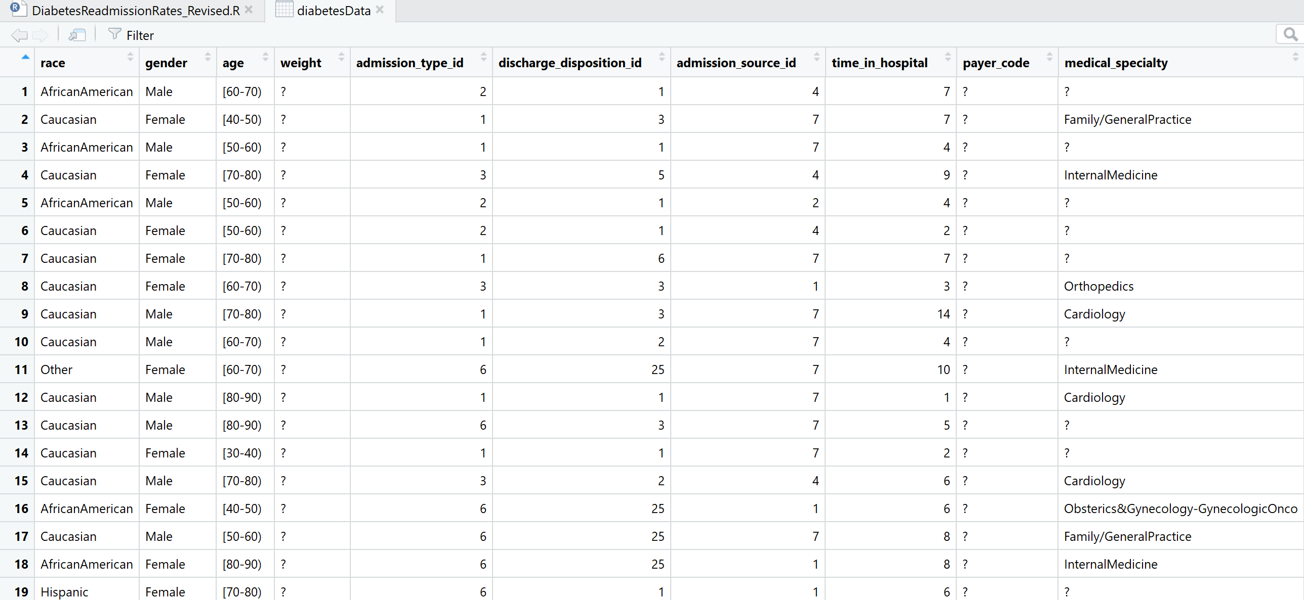

A quick overview shows that there are a lot of missing values in the attributes especially with respect to the columns ***weight*** and ***payer code***. Hence, those columns were also removed, and the dataset was tested for NA’s.



The results were further narrowed down to find which specific columns had NA’s and they were accordingly treated. The NA’s in ***race*** and ***medical specialty*** were converted to Unknown and the values of diagnoses columns were converted to zero.

The important column in this dataset is the ***readmitted*** column which is the column we want to be able to predict and is the same column that is going to be used to see how other variables in the dataset affect the readmission column. This column was recoded for easy use. The value “>30” was recoded to 2, “<30” recoded to 1 and “No” was recoded to zero.

The attribute ***medical specialty*** was also recoded with numbers for each of the department names.

NULL values were removed from some of the columns like ***admission type, admission source id***and ***discharge disposition id***. These values were removed only because they don’t contribute to our specific analysis.

The next step was to look at the structure of the dataset and make changes to some of the variables by converting them to the right data type. If the variable is not of the right data type, it can jeopardise the analysis altogether.

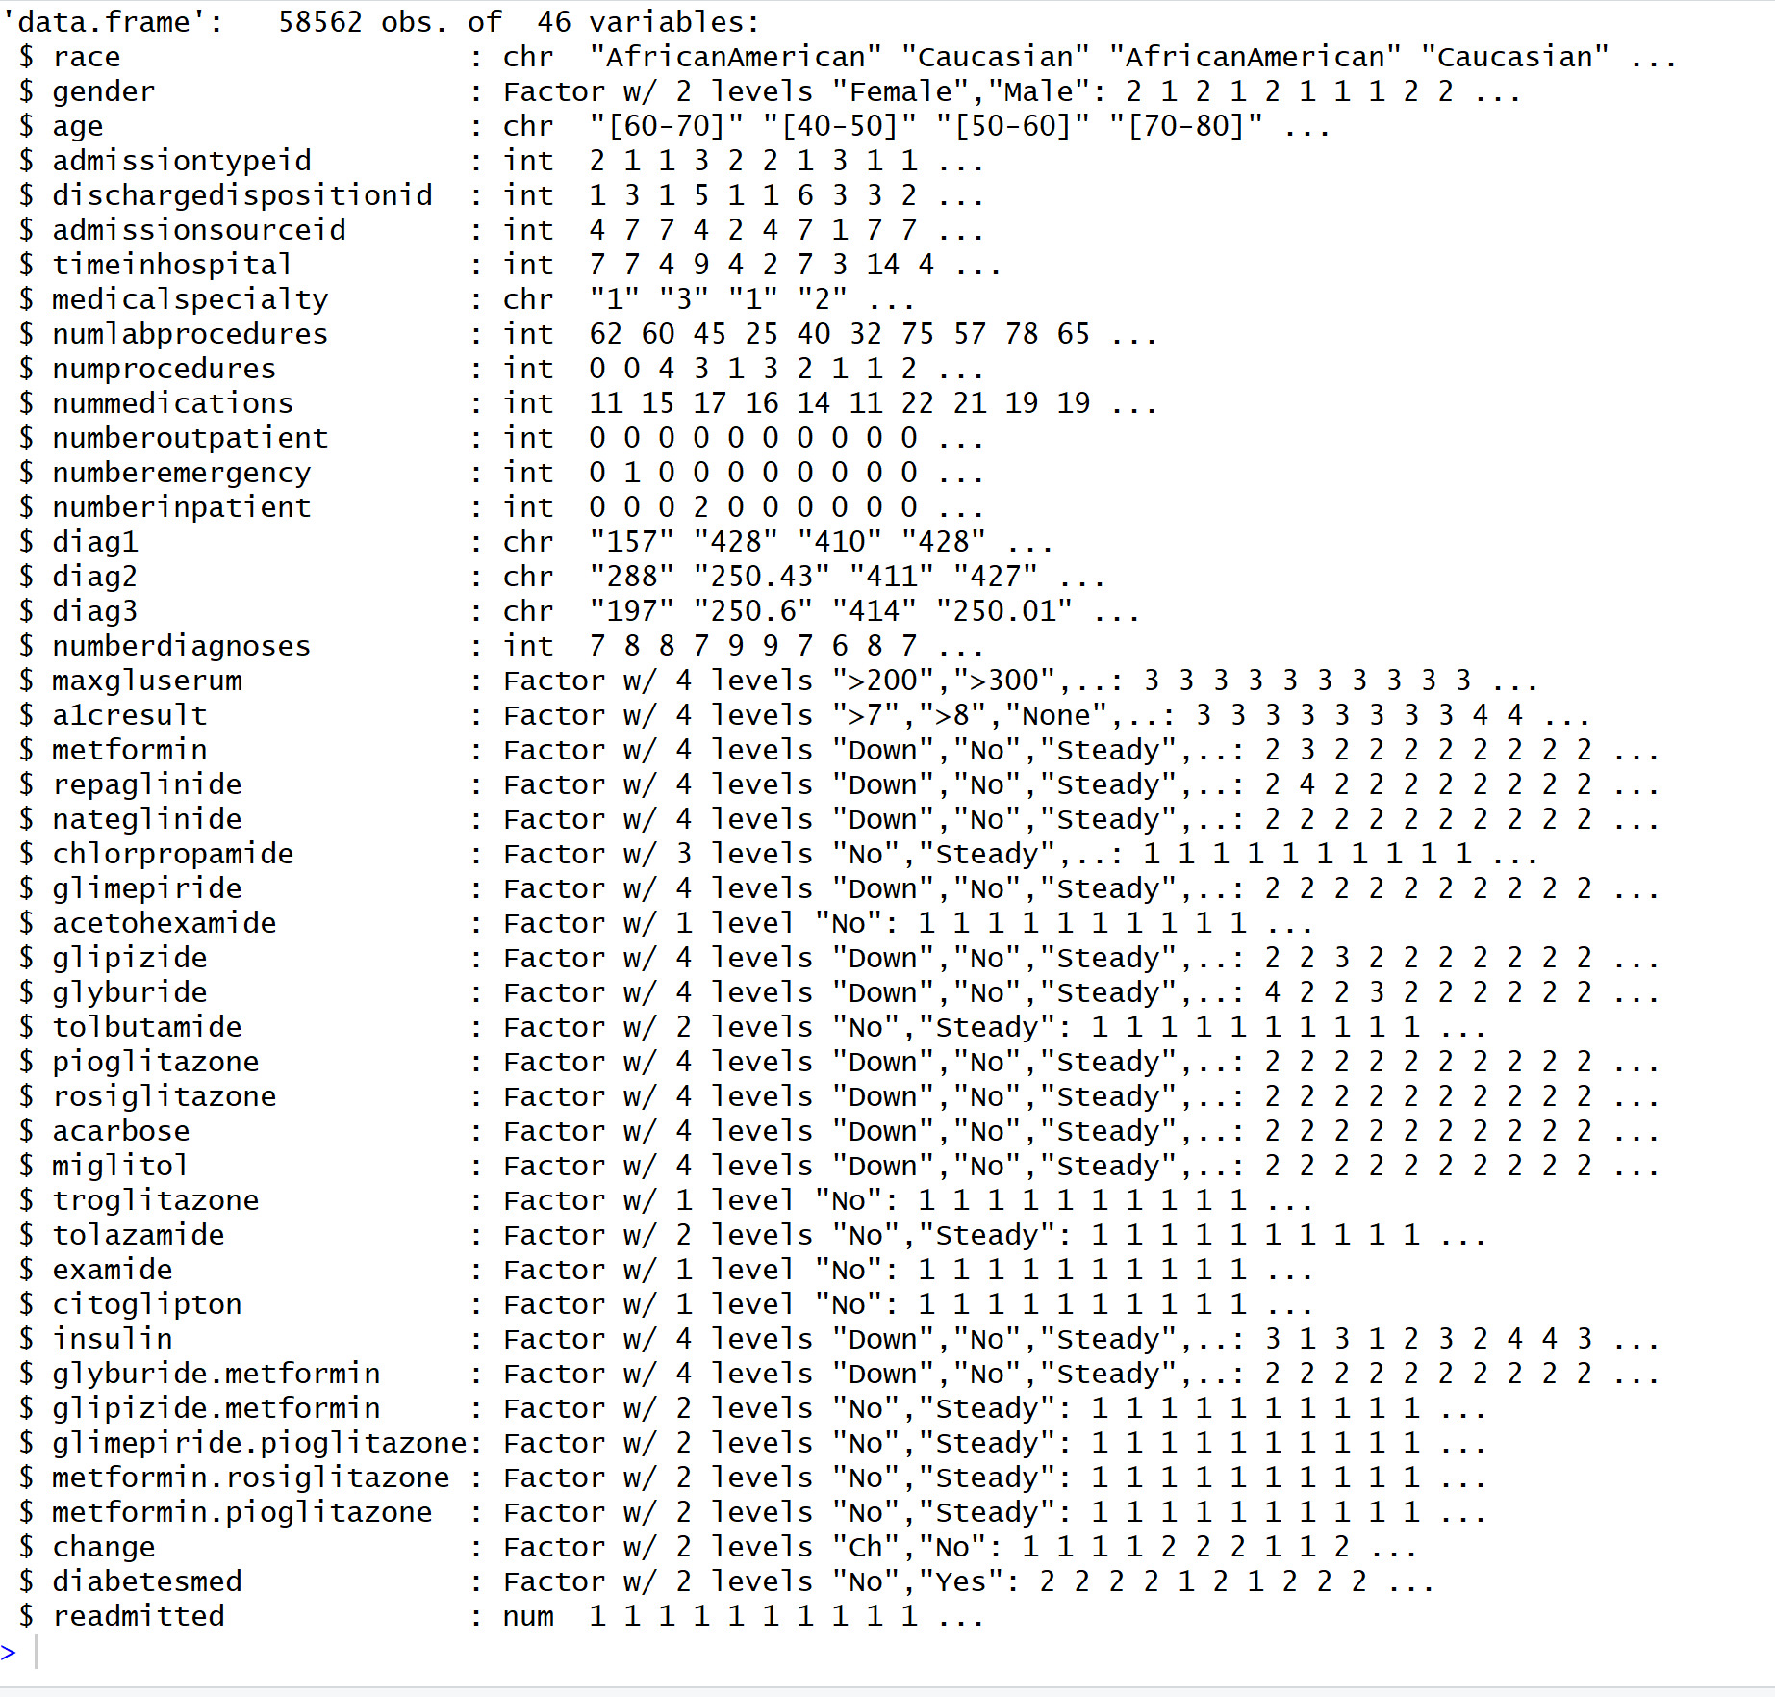

Variables ***race, age, admission type id***was converted to factor datatype since these are nominal variables.

For easy understanding, the ***diagnosis1*** variable was recoded with the department name itself instead of the numeric codes. The same was applied to the other two similar columns diag2 and diag3. These variables were also converted to a factor datatype.

Similarly, the variable ***age*** was also recoded with character values like ‘child’, ‘teens’, ‘twenties’ and so on.

The next column to be discretized was the medical specialty column. The discretization was based on the below conditions. Depending on which department the physician came from, the assignment of the numbers was done.

* 1-Unknown, 2–Obstetrics & Gynaecology, 3-Psychology, 4-Sports & Ortho, 5-family medicine and others, 6-Pediatrics, 7-Surgery, 8-All other fields of medicine.

Attribute ***num procedures*** was discretized as below:

* If the number of procedures done on the patient is less than or equal to three -> 1
* If the number of procedures done on the patient greater than three -> 2

Attribute ***num lab procedures*** was discretized as below:

* If the number of lab procedures done on the patient is less than or equal to 44 -> 1

If the number of lab procedures done on the patient greater than 44 -> 2

Attribute ***time in hospital*** was discretized as below:

* If the number of days spent in the hospital by the patient is less than or equal to 5 -> 1
* If the number of days spent in the hospital by the patient is less than or equal to 10 but greater than or equal to 6 days -> 2
* If the number of days spent in the hospital by the patient is less than or equal to 14 but greater than or equal to 11 days -> 3

Another column that is important for the analysis is the ***discharge disposition id***, which tells us where the patient was discharged to after the hospitalization. If one looks at the IDs_mapping.csv provided by UCI, it can be inferred that the values 11,13,14,19,20,21 are related to death or hospice. These samples from the predictive model since they cannot be readmitted. This attribute was further discretized as follows:

* 1: Discharged to Home 2: Discharged to Another Facility\Hospital 3: Admitted 4: Unknown

Attribute ***admission source id*** was discretized as below:

* 1-Referrals 2-Transfers 3-Admission from a different department 4-Unknown

All the above discretized attributes were converted to factor datatype in addition to the readmitted attribute. Once again, the structure of the data frame is viewed to make sure everything is of the right data type.

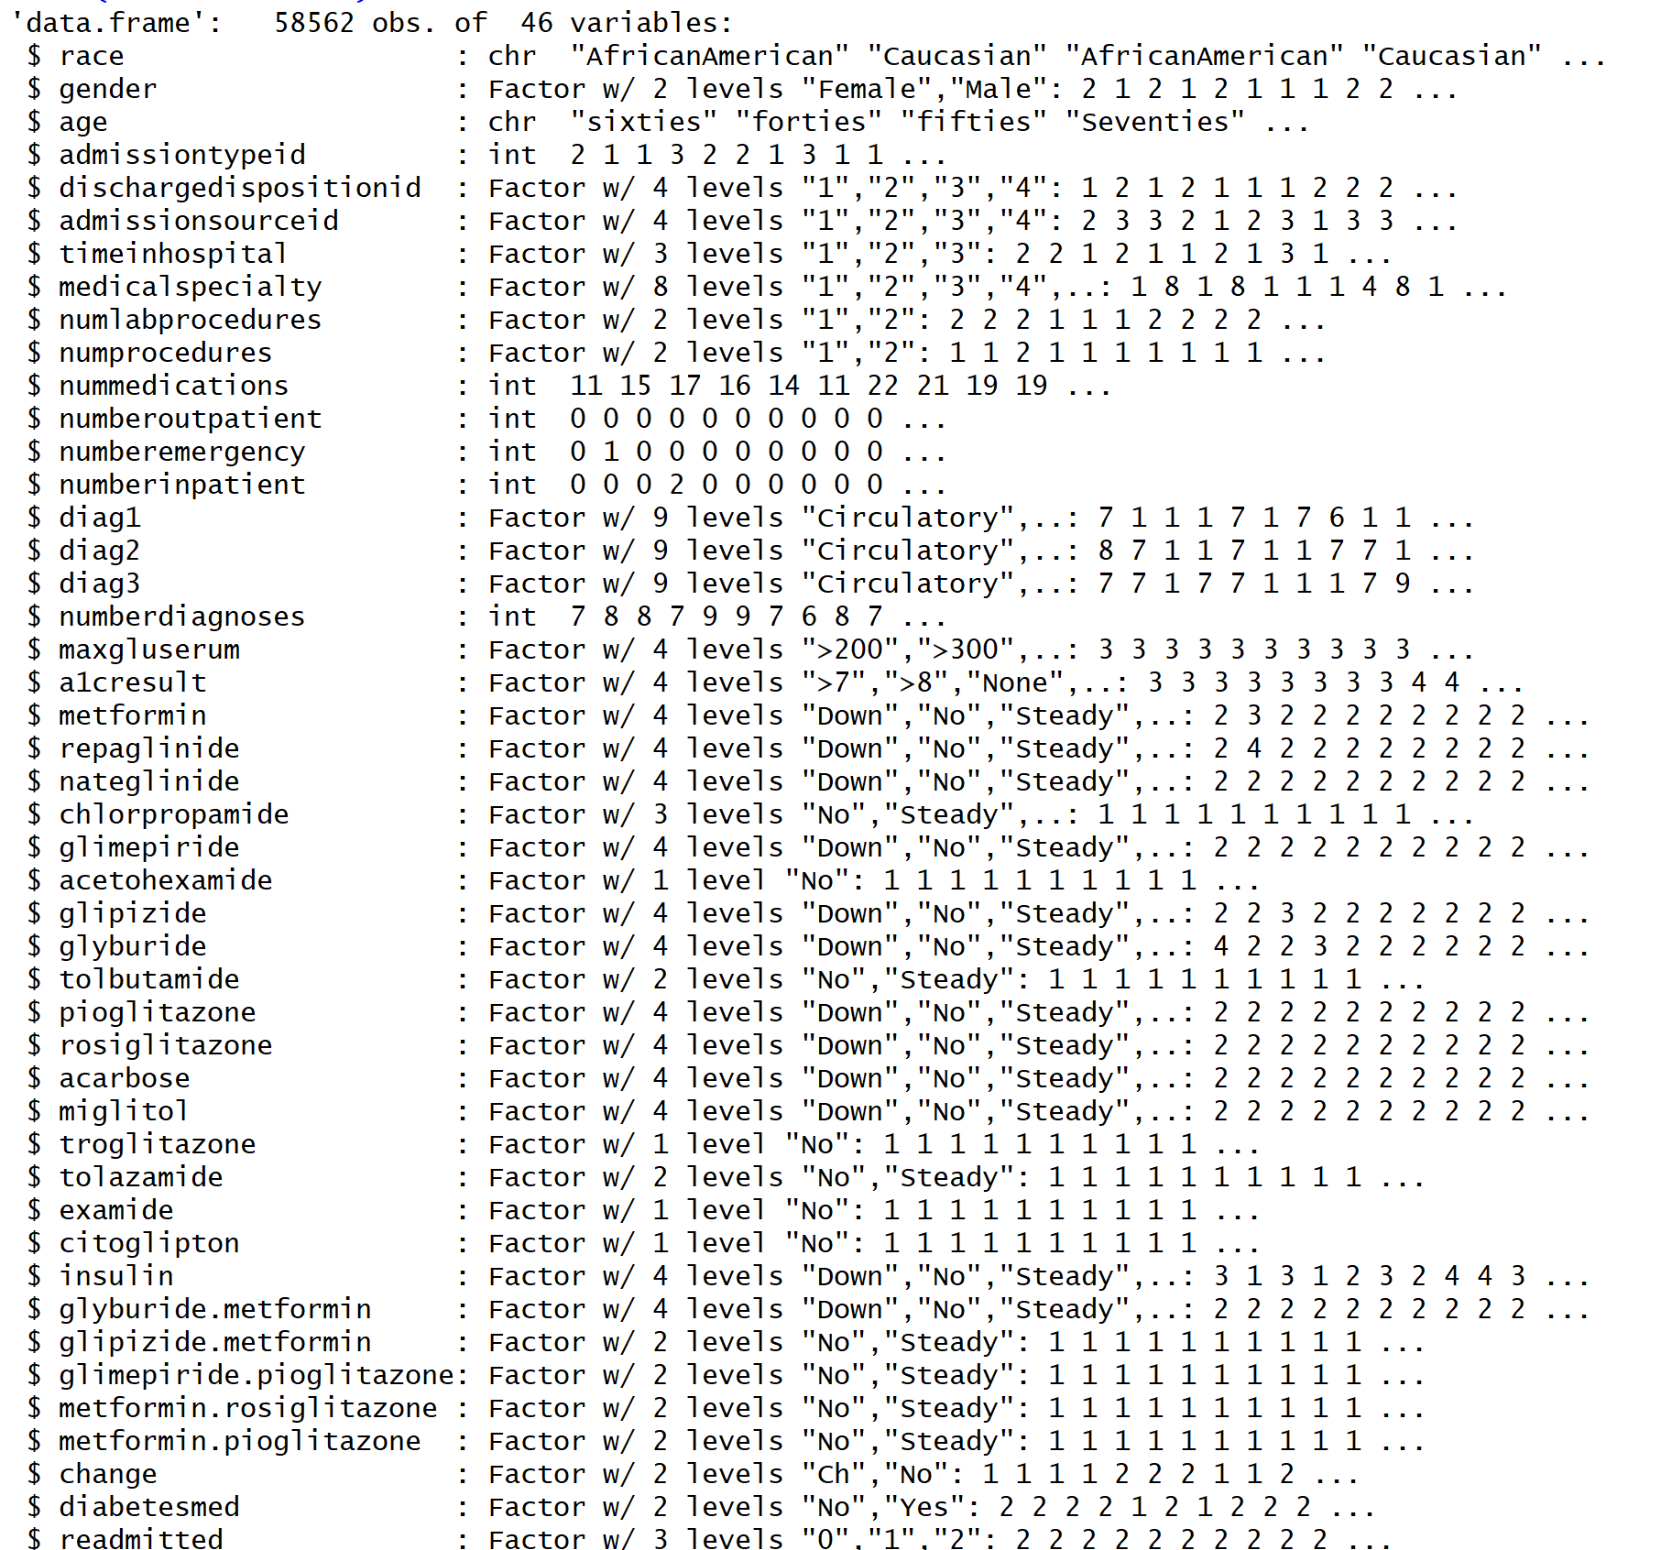

Note that the analysis won’t work and will throw errors if an attribute which is of factor datatype has only one level. And that’s why the attributes ***examide, citoglipton, troglitazone*** and ***acetohexamide***were removed from the dataset. This doesn’t conclude the data cleaning and pre-processing. This is a continuous process since analyses will bring in more insights to the data and lead to more change. Another important fact is that different techniques need differently processed datasets. For Clustering, the dataset was converted into a all-numeric dataset and normalized using normalization functions. To apply Decision Tree algorithms, the dataset was recoded into a categorical dataset to see if the algorithm performed differently on different dataset types.

Now, its time to do some exploratory data analysis to determine further steps in the process.

**Exploratory Data Analysis**

Different attributes were selected and visualized to see their ranges and what stories the data tells. The below bar chart visualizes the readmission rates by age and shows how patients in their sixties and seventies are the ones with higher readmission rates and those are the same sector of patients who have high percentages of no readmission rates as well.

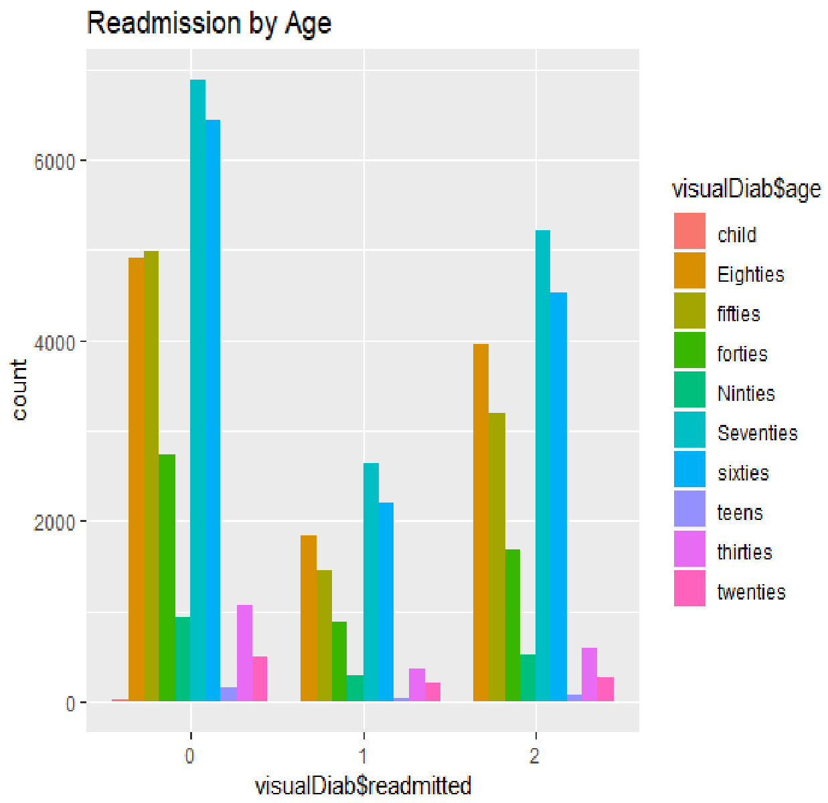

More bar charts were visualized to show the readmission rates by Gender and Race. Here, females topped the list in every level wherein they were the highest number of patients in both the readmission and no readmission aspects. Also, the patients belonging to Caucasian race formed the higher percentage of patients altogether. What this tells us is the fact that we need more data on readmitted patients to be able to draw better insights.

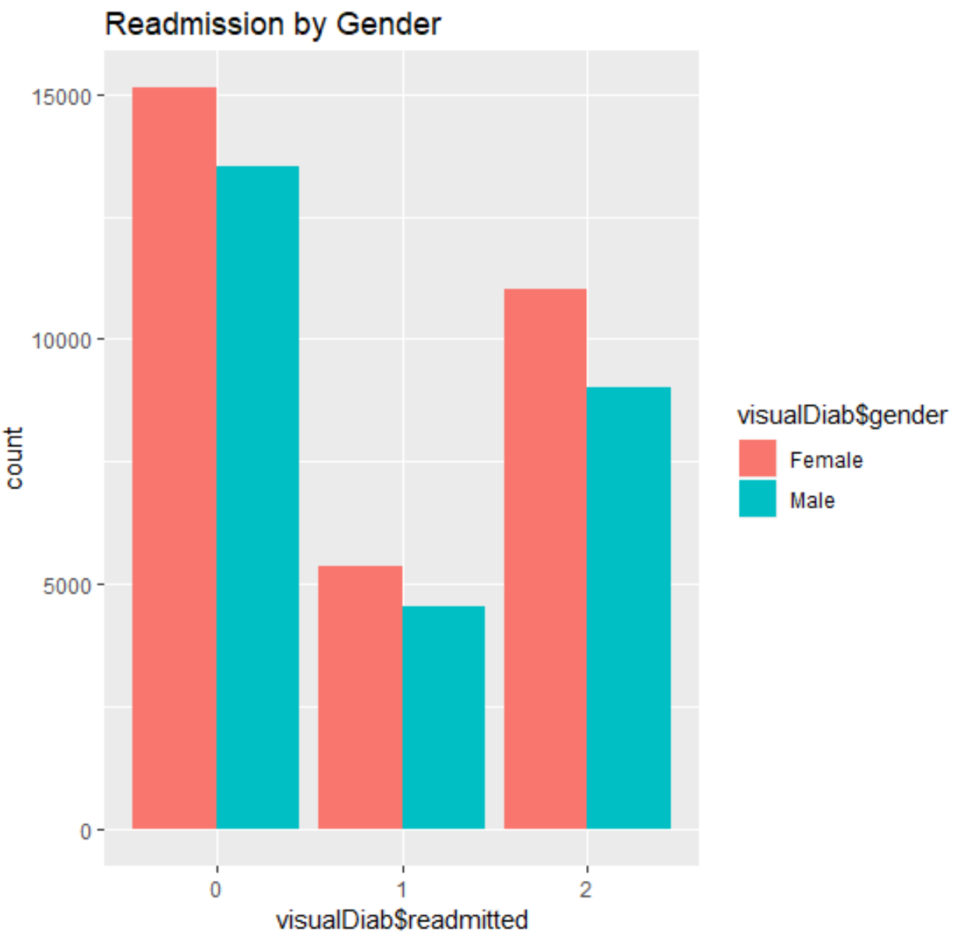

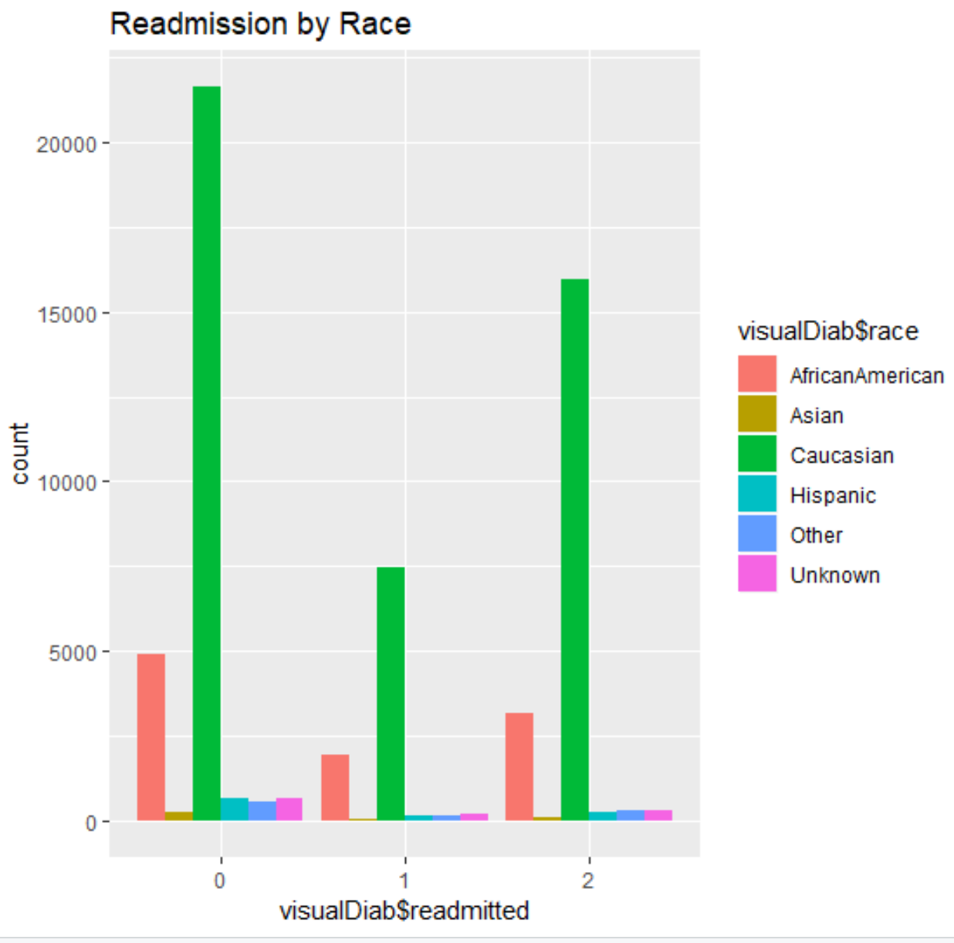

The next bar plot visualizes the readmission rates by admission type id where the highest number of patients in any category of readmission are the ones who were admitted through emergency.

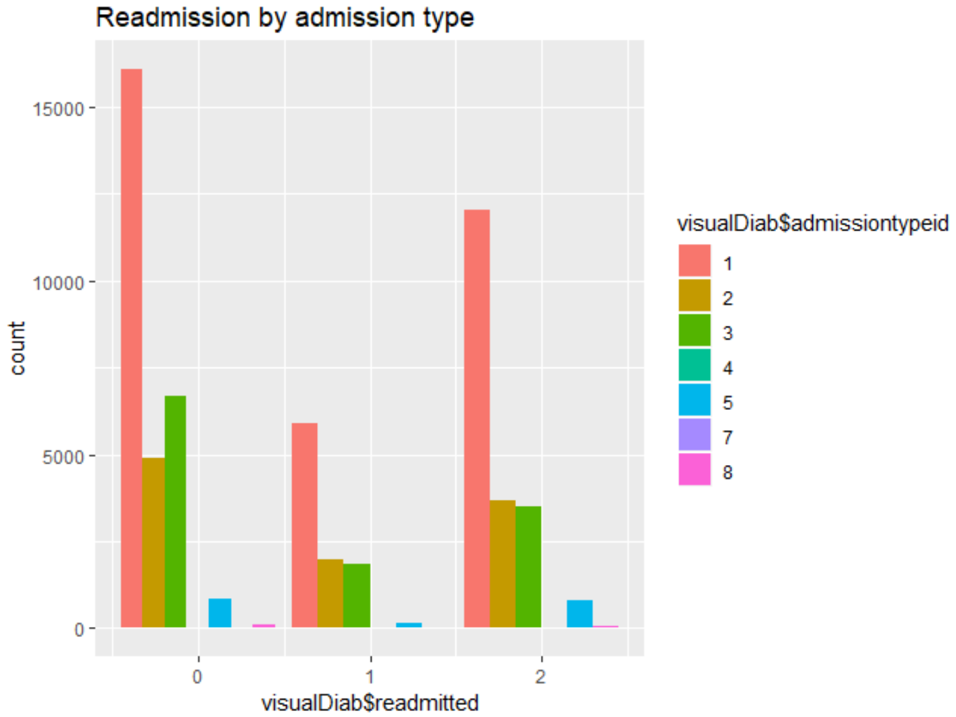

The below plot visualizes the readmission rates by discharge disposition id where the highest number of patients in any category of readmission are the ones who were discharged to home\hospice care.

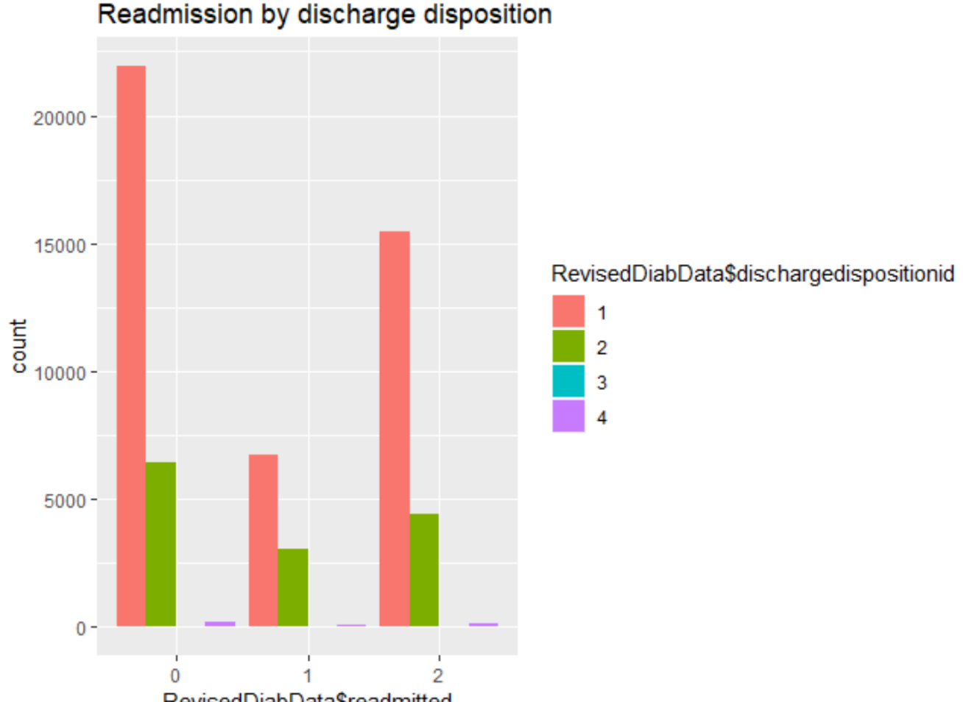

The next bar plot visualizes the readmission rates by admission source id where the highest number of patients in any category of readmission are the ones who were admitted from different departments of the same hospital.

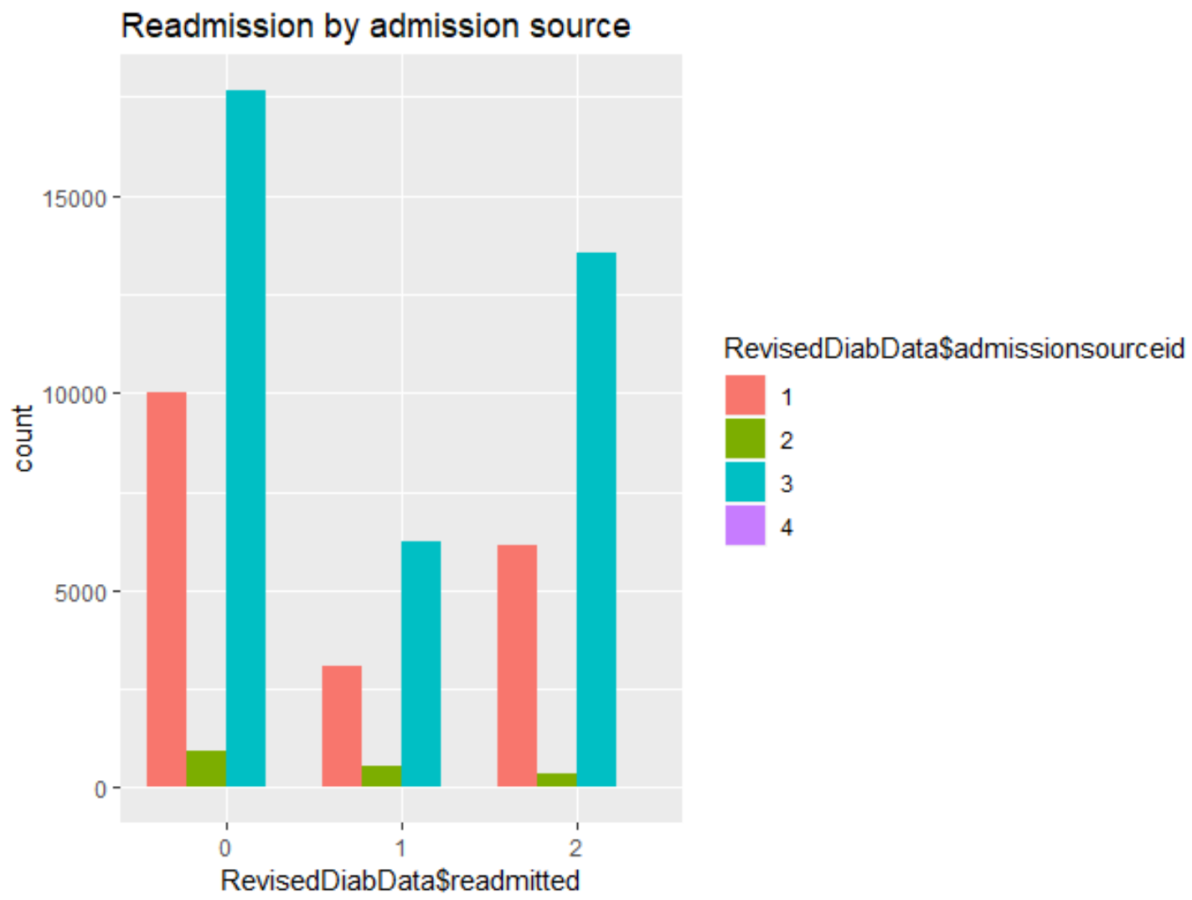

The next bar plot visualizes the readmission rates by number of outpatient visits in the year preceding the encounter. It can be inferred that patients with the highest number of outpatient visits were the ones who never got readmitted.

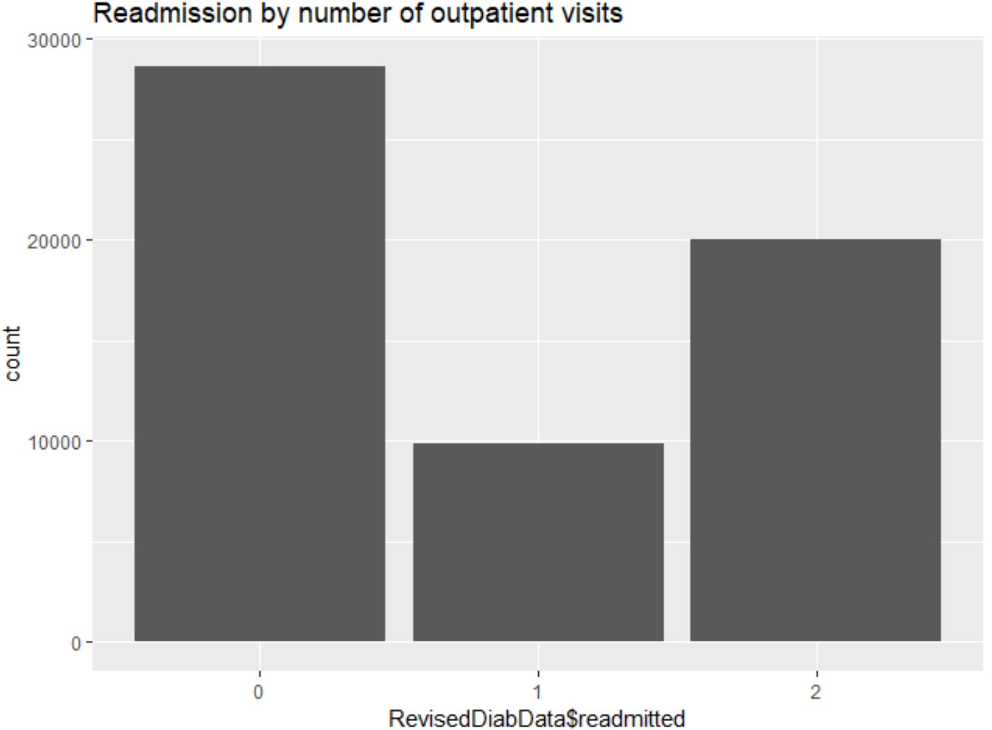

The next bar plot visualizes the readmission rates by number of inpatient visits in the year preceding the encounter. It can be inferred that patients with the highest number of inpatient visits were the ones who never got readmitted.

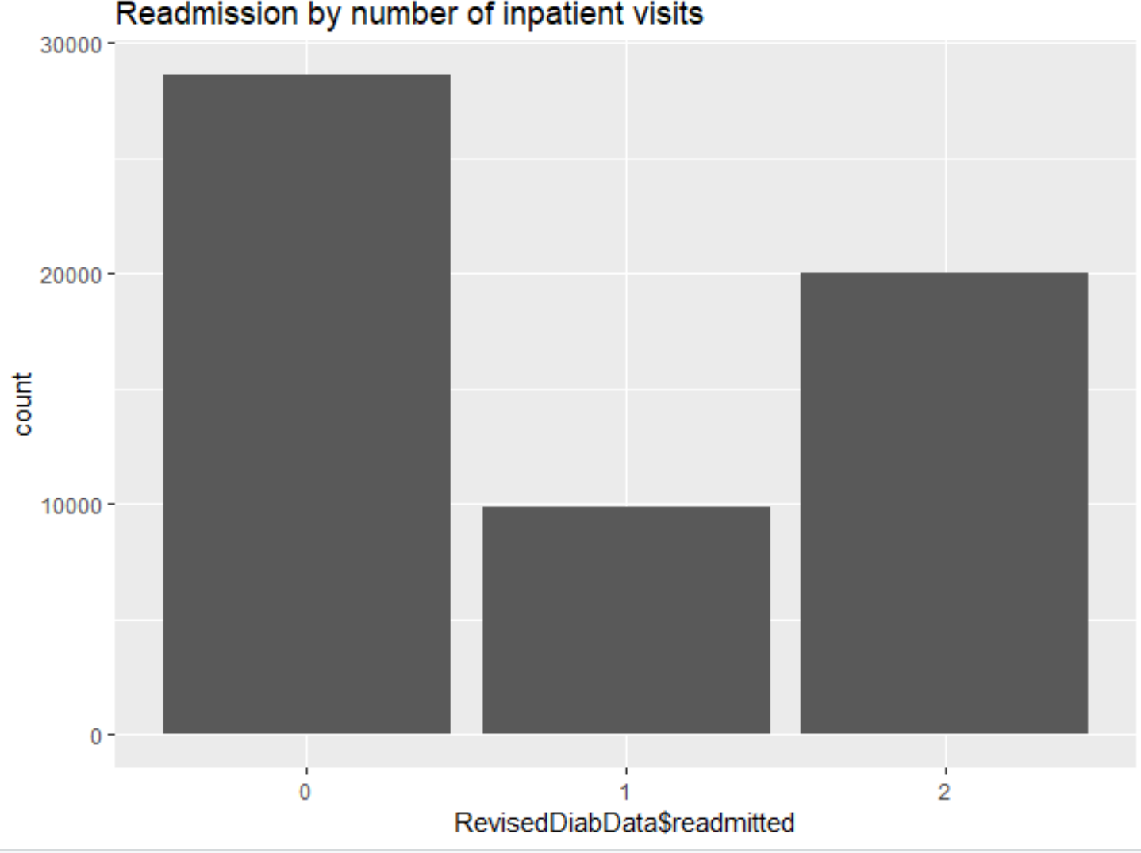

This plot visualizes the readmission rates by number of emergency visits in the year preceding the encounter. It can be inferred that patients with the highest number of emergency visits were the ones who never got readmitted.

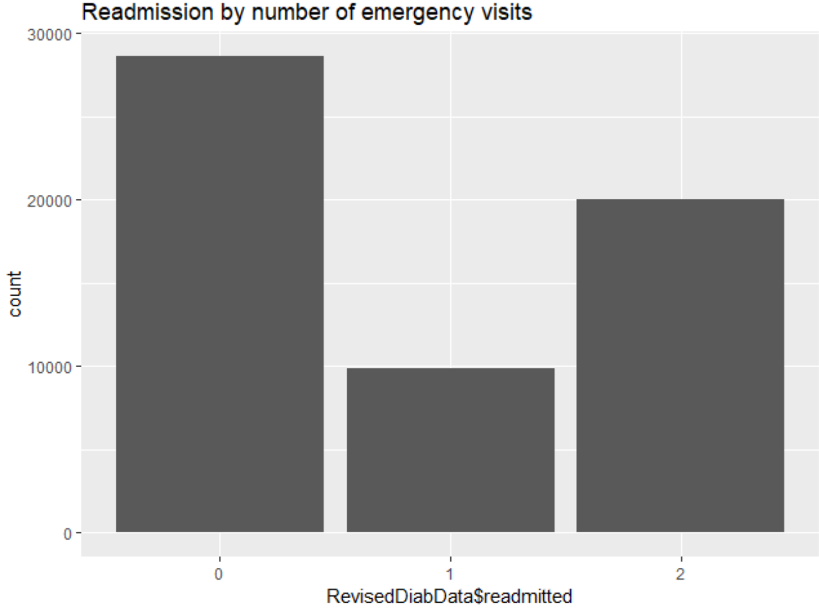

The below bar plot visualizes the readmission rates by a1c test results where the highest number of patients in any category of readmission are the ones who were never ordered the test results for.

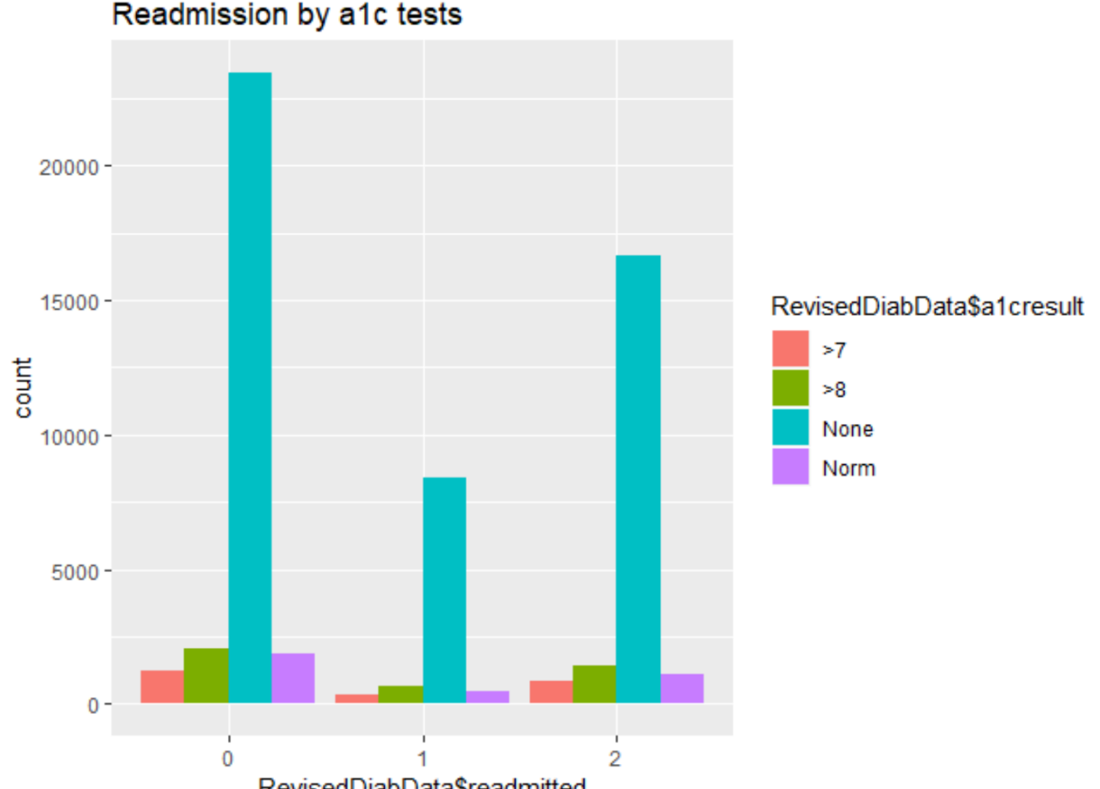

The below bar plot visualizes the readmission rates by diabetes medications where the highest number of patients in any category of readmission are the ones who were ordered to take the medications.

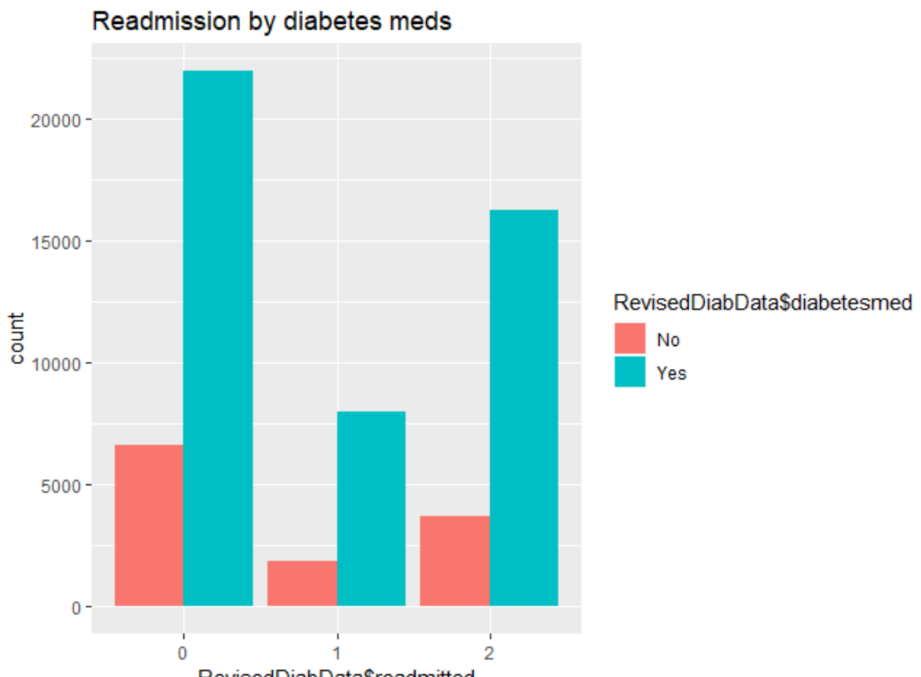

The below bar plot visualizes the readmission rates by number of lab procedures, and it can be inferred that patients who were readmitted in the future had a higher number of lab procedures performed on them than on the ones who were not.

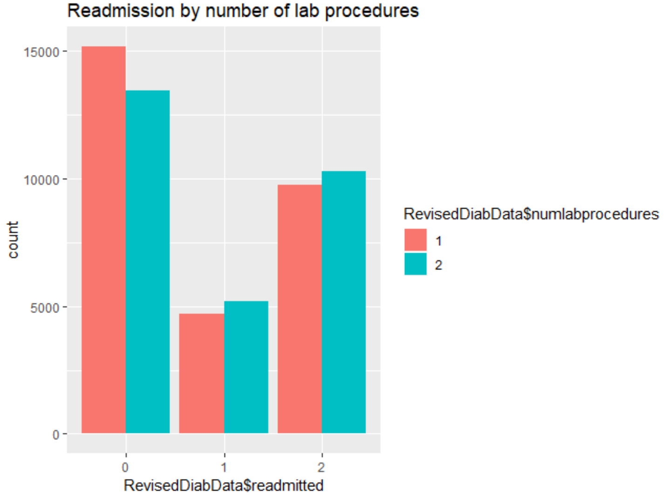

The below visualization shows that the number of procedures ordered on the patients are less than equal to 3.

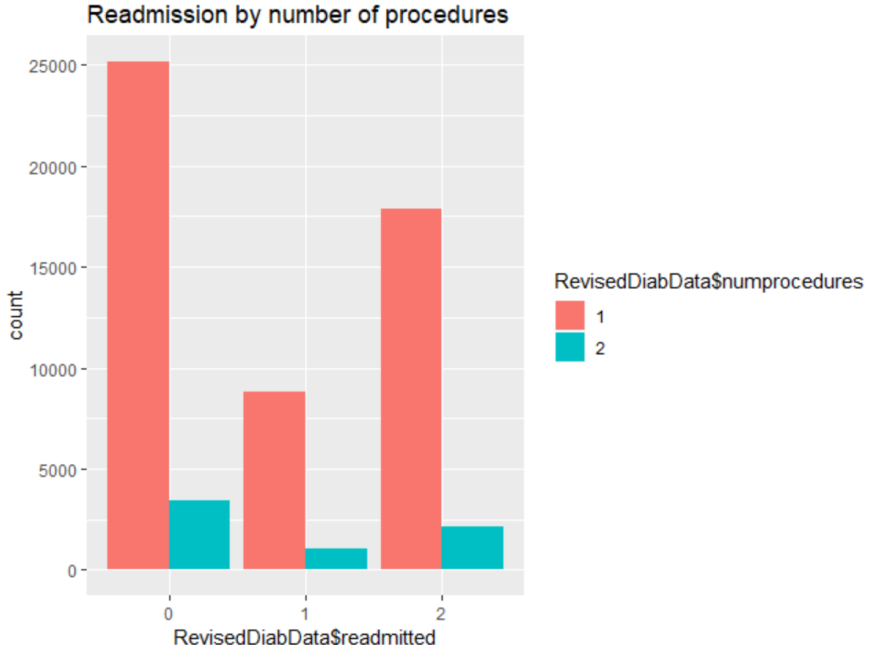

The below plot shows that the greatest number of patients spent only 1 to 5 days in the hospital.

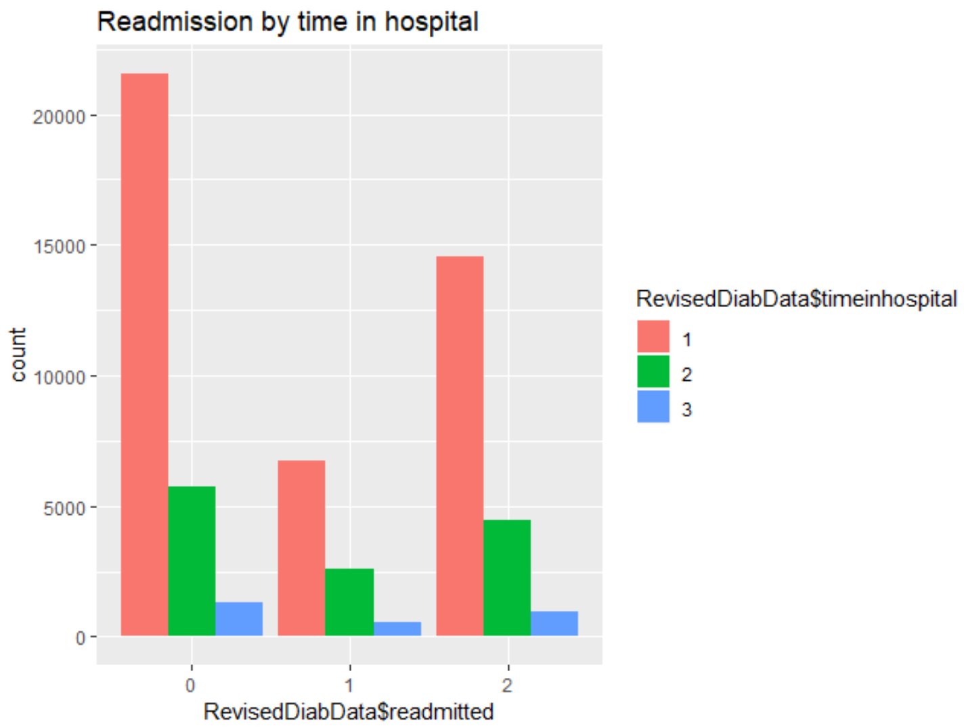

Next, a correlation matrix was visualized to understand the correlations between integer variables and possibly eliminate one of the pairs with high correlations.

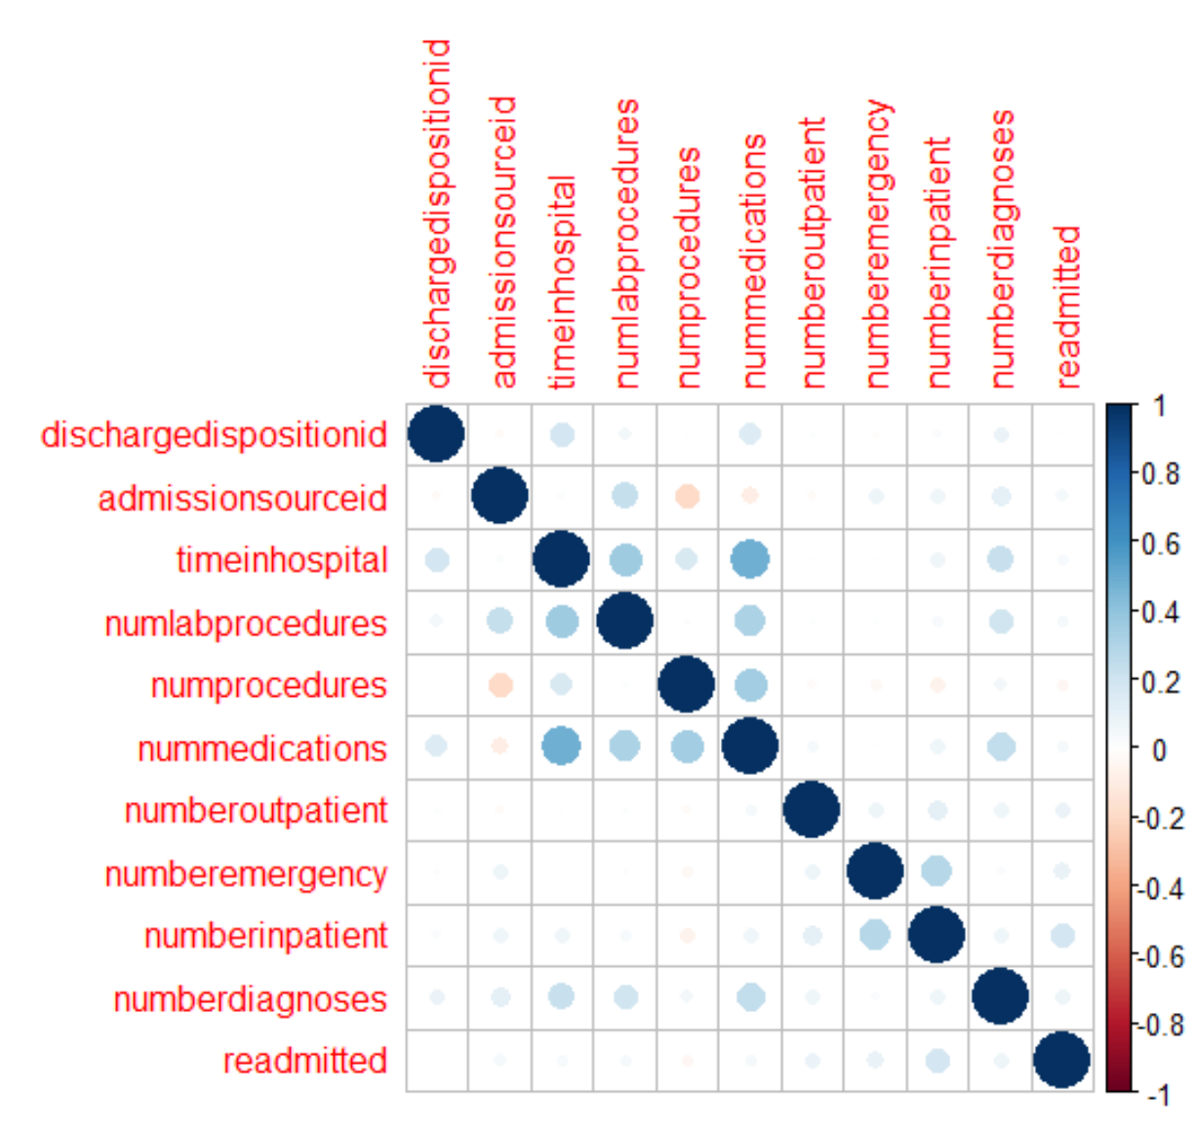

The above matrix shows that there is a strong positive correlation between the variables ***nummedications***and ***timeinhospital***denoting that when the number of days a patient spends in the hospital increases, the number of medications administered to the patient also increases which makes intuitive sense. So, removing one of these variables for further analysis will prevent skewing. Variable ***nummedications*** was removed in this case.

To find correlations between the rest of the non-numeric variables, variables were recoded with integers and converted to numeric datatype just for this specific purpose.

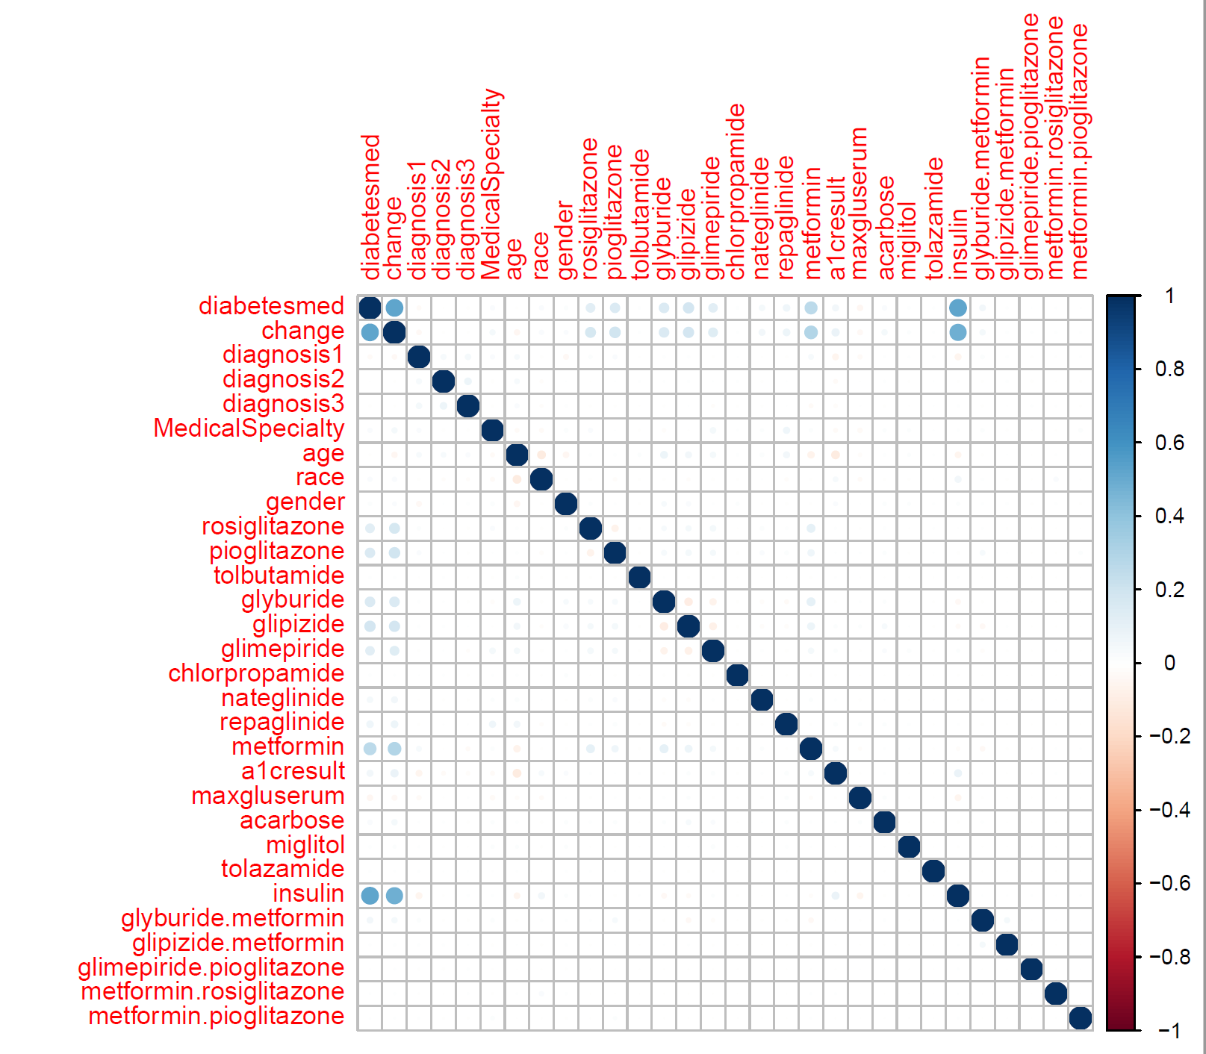

The resulting graph shows a high positive correlation between the variables diabetesmed and change & insulin has a correlation between both the variables diabetesmed and change. Hence, the variables ***Change*** and ***Insulin*** were removed from the dataset for further analysis.

Moving on to applying some of the unsupervised and supervised methods on this dataset to study them.

**Association Rule Mining Technique**

Association rule mining is a procedure which is meant to find frequent patterns, correlations, associations, or causal structures from data sets found in various kinds of databases such as relational databases, transactional databases, and other forms of data repositories. Given a set of transactions, association rule mining aims to find the rules which enable us to predict the occurrence of a specific item based on the occurrences of the other items in the transaction.

The best or the most interesting rules are found by looking at the support, confidence and lift values. This technique uses the apriori algorithm as a search strategy to count the support of item sets and give the rules. Apriori is the algorithm function name and the parameters supplied are the support and confidence thresholds with a maximum length of items in the resultant rules.

What does the support and confidence threshold mean? Support is an indication of how frequently the itemset appears in the dataset. For example, if the support value of an itemset is 0.2, it means that the itemset appears in 20% of all the transactions.

Confidence is an indication of how often the rule has been found to be true. For example, if a rule has a confidence value of 0.9, it means that for 90% of transactions, when the items on the LHS of the rule are bought, the item or items on the RHS are bought as well.

There is another value called lift which is also important in understanding the probability of occurrence of a specific rule. If the rule had a lift of 1, it would imply that the probability of occurrence of the antecedent and that of the consequent are independent of each other. When two events are independent of each other, no rule can be drawn involving those two events. If the lift is > 1, that lets us know the degree to which those two occurrences are dependent on one another and makes those rules potentially useful for predicting the consequent in future data sets. If the lift is < 1, that lets us know the items are substitute to each other. This means that presence of one item has negative effect on presence of another item and vice versa.

To run the apriori algorithm on a dataset, all the variables should be of factor datatype or only those variables that are factors should be used. Once the required packages (arules, arulesviz) were loaded, the algorithm was run on the diabetes dataset with a low support value of 0.001, high confidence of 0.08 and minimum length of the rules set to 2. Also, the right-hand side of the rule was set to the ***readmitted***column to find out what factors drive patients to get readmitted to hospitals in less than 30 days and the left-hand side was set to default. The resulting output was sorted by confidence and the top 20 rules were viewed.

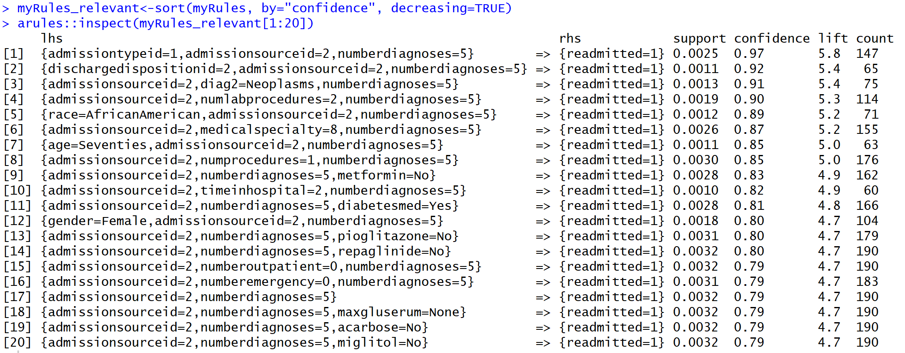

Some interesting associations were identified from these rules. Rule#1 shows that when the patient is admitted through emergency and was transferred from another hospital\facility into this hospital and when the number of diagnoses made on the patient is equal to 5, there is a 97% confidence level of patients getting readmitted. The high lift for this rule is 5.8 signifies the high probability of the LHS and RHS factors occurring are dependent on one another.

Rule#2 shows that when the hospital discharges the patient to another hospital and when the patient was transferred from another hospital\facility into this hospital and when the patient has at least 5 diagnoses, there is a 92% chance of patients getting readmitted to the hospital.

Rule#5 shows that African American patients who were transferred from another hospital with at least 5 diagnoses have 89% chances of getting readmitted.

An interesting rule (rule#3) amongst these rules is the fact that patients who were diagnosed (secondary diagnosis) as having issues in the Neoplasms department along with the other two factors (the patient must have been transferred from another hospital and the number of diagnoses should be equal to 5), have a 91% chance of getting readmitted.

Another rule(rule#18) shows that patients who were not measured for glucose serum tests along with the other two factors (the patient must have been transferred from another hospital and the number of diagnoses should be equal to 5), had a 79% probability of getting readmitted later. Even though this probability is not as high as those other rules that was just discussed, this is still quite significant in the fact that glucose serum test is a very important factor for diabetic patients.

A very intriguing rule among this is rule#11 which says that patients who were admitted into this hospital as a transfer from another hospital and who at least had 5 diagnoses and to whom diabetes medications were prescribed had an 81% probability of getting readmitted.

Note that all the above rules that were discussed had a high lift value suggesting the level of dependence among these attributes. These rules were also visualized using a scatter plot and graph that is shown below to be able to analyze it better.

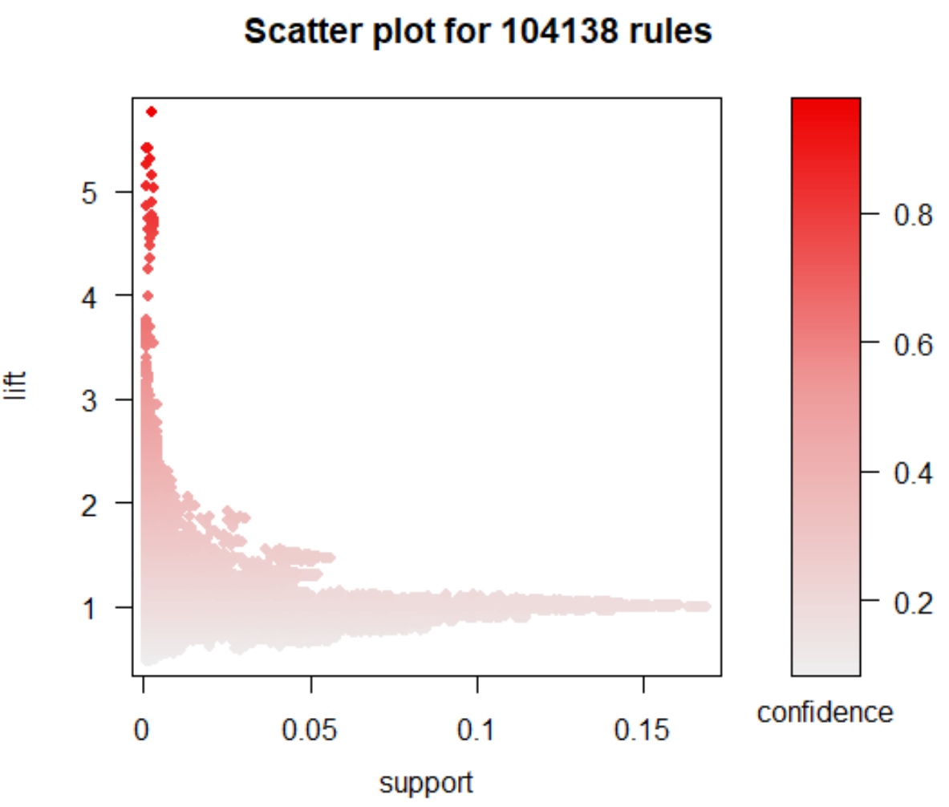

The above scatter plot shows that there are only a few important rules which have high lift, low support and high confidence.

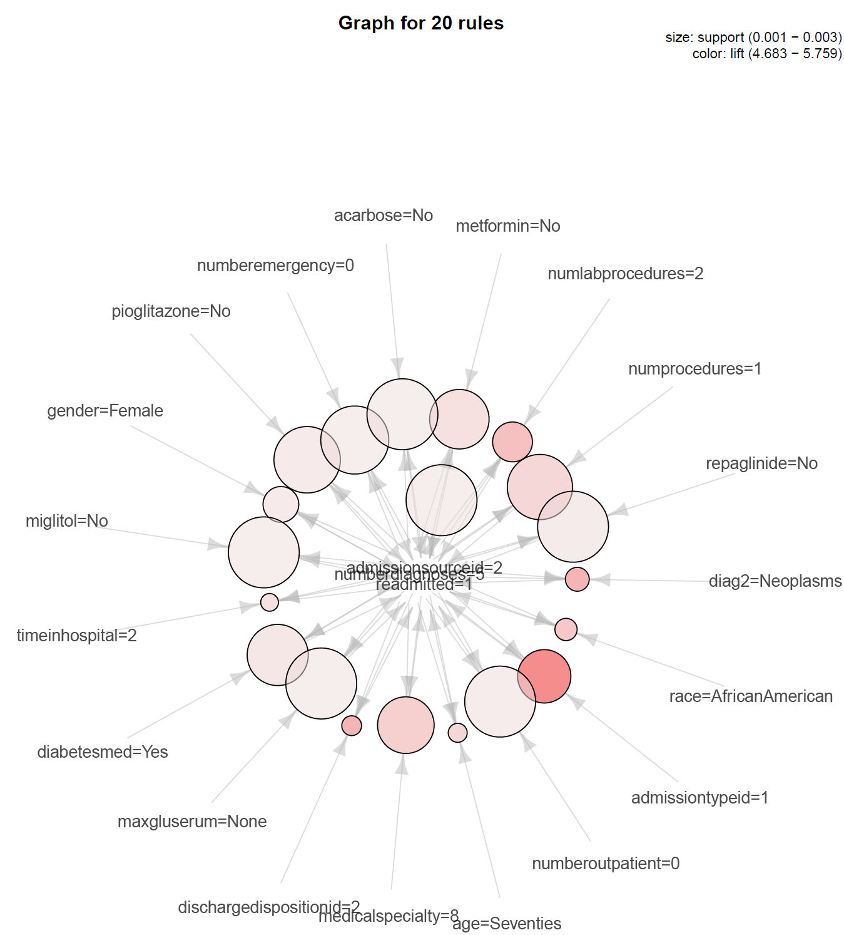

To scan more interesting rules, the algorithm was run again with the same tuning parameters except for the value of *rhs* which was set to readmitted=0 to understand the factors associated with non-readmissions.

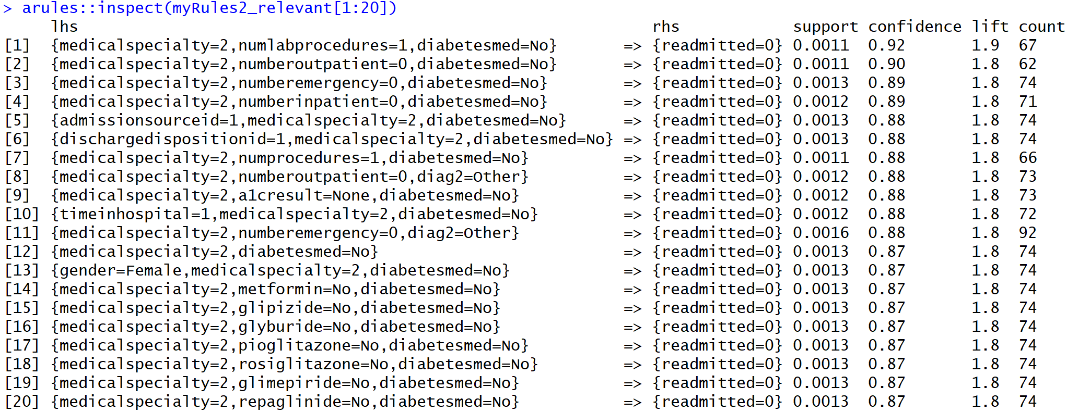

Examining the above rules, a common association between patients who were successfully diagnosed and not readmitted were those patients who were admitted by a physician from the Obstetrics and Gynaecology specialty.

Along with the above fact, rule#1 shows that if the number of lab procedures performed on the patient is equal to 1 AND if there was no change in the diabetes medications, there is a 92% probability that the patient will not get readmitted.

Also, the patients who were admitted by the Ob&G physicians and who never had any inpatient or outpatient or emergency visits in the year preceding the encounter and whose diabetic medications were not changed are the ones who don’t get readmitted with a high probability of 90% and a lift greater than 1.

There is also a high confidence of 88% probability that patients admitted by Ob&G physicians and later discharged to home and who were not administered diabetic medications never getting readmitted. Below is the visual representation of these rules.

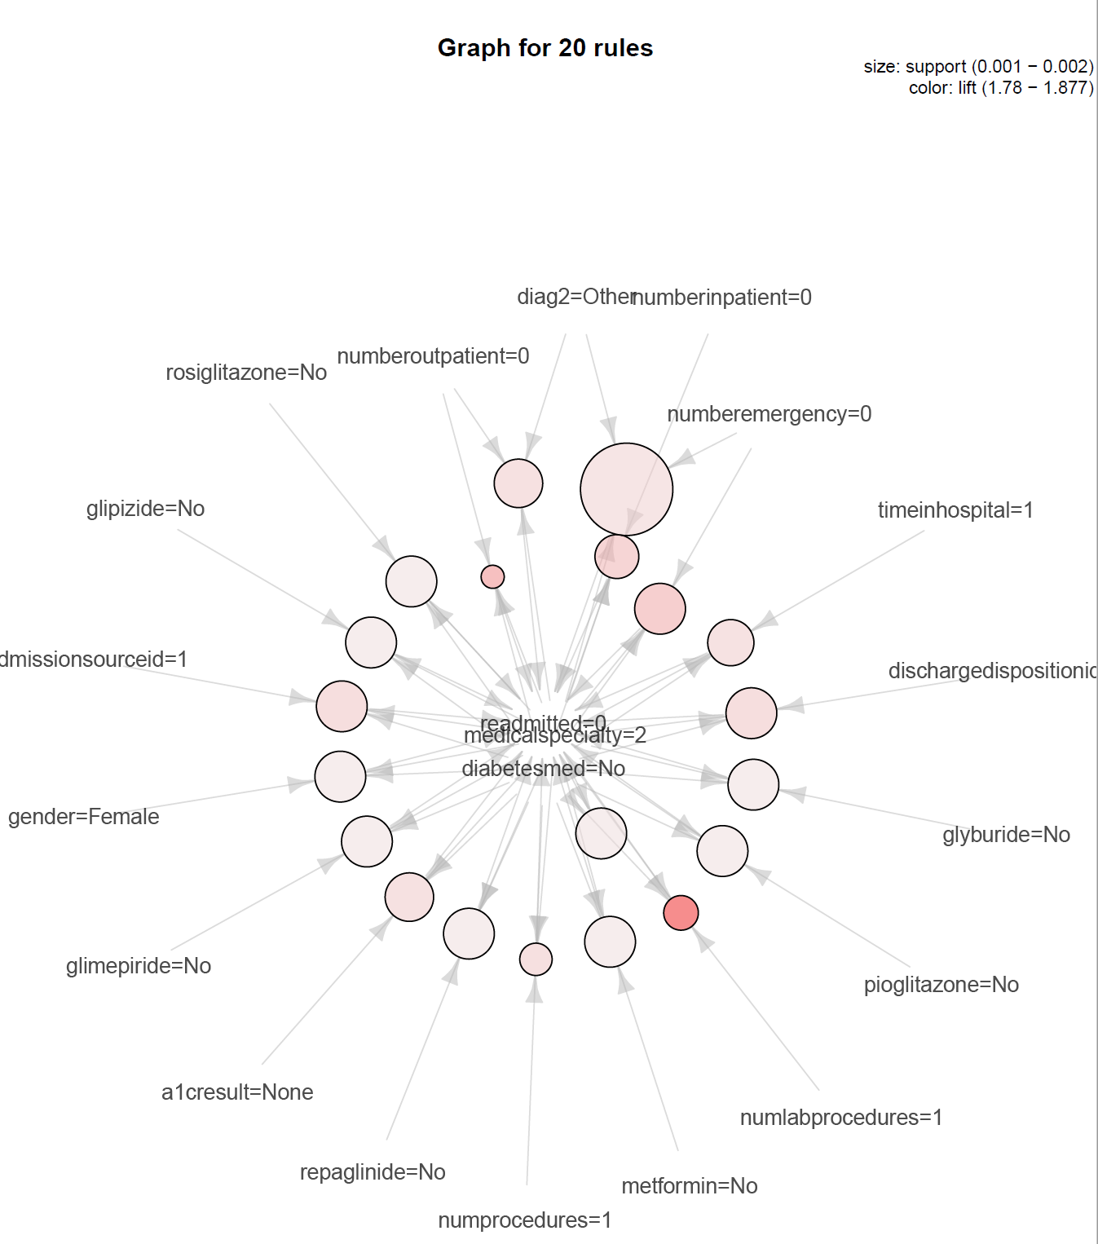

The algorithm was run for a third time by setting the readmitted variable on the right-hand side to be set to 2 (meaning those records where the patients were readmitted to the hospital greater than 30 days of being discharged).

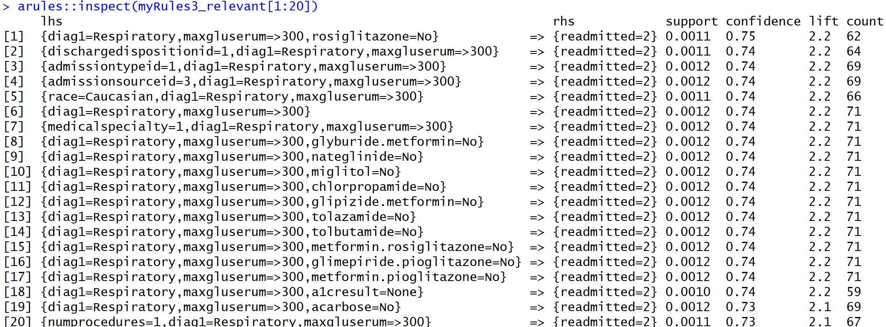

The reasoning behind using this logic to generate rules based on readmission rates greater than 30 days is to see what factors drive the patients to not get readmitted sooner but later.

It can be inferred that there is a 75% probability of patients primarily diagnosed with respiratory illness with their glucose serum levels being greater than 300 and who were not administered with the medicine rosiglitazone getting readmitted more than 30 days of being discharged. Almost all the top 20 rules here show that the patient primarily diagnosed with respiratory illness with a glucose serum level greater than 300 has been readmitted after 30 days of being discharged.

Below is the visual graph of the rules. All of them show a high support and lift value as well.

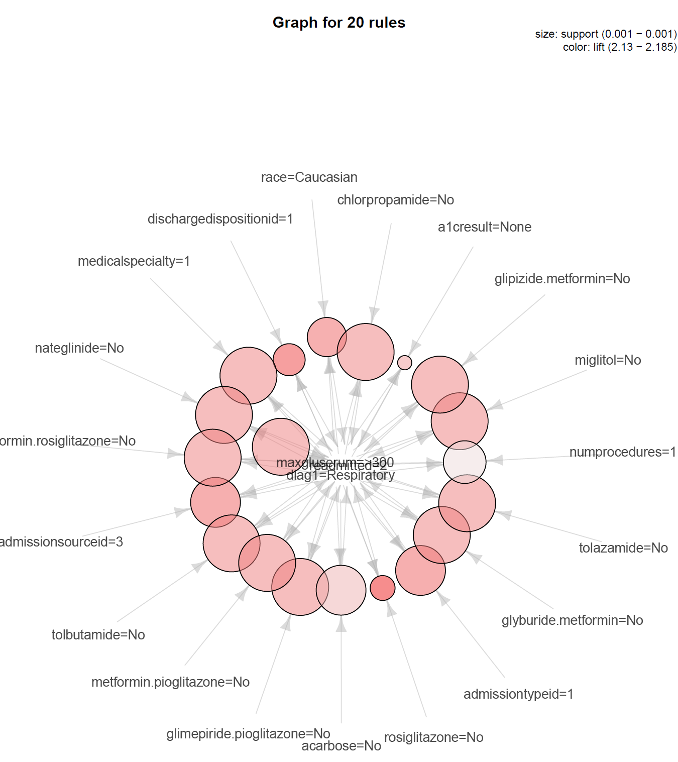

**Clustering Techniques**

As per the definition provided in the book ‘Introduction to Data Mining’, cluster analysis groups data objects based only on information found in the data that describes the objects and their relationships. The goal of cluster analysis is to group similar objects in a cluster and different from the objects in other groups. There are different types of clustering techniques and different types of clusters. For the analysis of the dataset in question, K-means clustering technique was chosen. Note that for clustering, one cannot use the same preprocessed dataset as the ARM since all variables were converted to factor type.

So, variables were recoded and converted to integer or numeric datatype to perform clustering on the dataset. Note that it is also important to normalize the dataset to make sure that all the columns in the dataset are of equal size to avoid skewness in the analysis. Once the dataset is normalized, the labels are added back to the dataset.

**K-means clustering**

K-means technique is a prototype-based, partitional clustering technique that attempts to find a user-specified number of clusters(K), which are represented by their centroids. This technique can be used to confirm business assumptions about what types of groups exist or to identify unknown groups in complex data sets. Once the algorithm has been run and the groups are defined, any new data can be easily assigned to the correct group. The algorithm iterates between two steps. First, K points are selected as initial centroids where K is a user-specified parameter. Second, K clusters are formed by assigning each point to its closest centroid. The centroid of each cluster is recalculated until the centroids don’t change.

In order to determine an optimal number for K, an elbow plot was created.

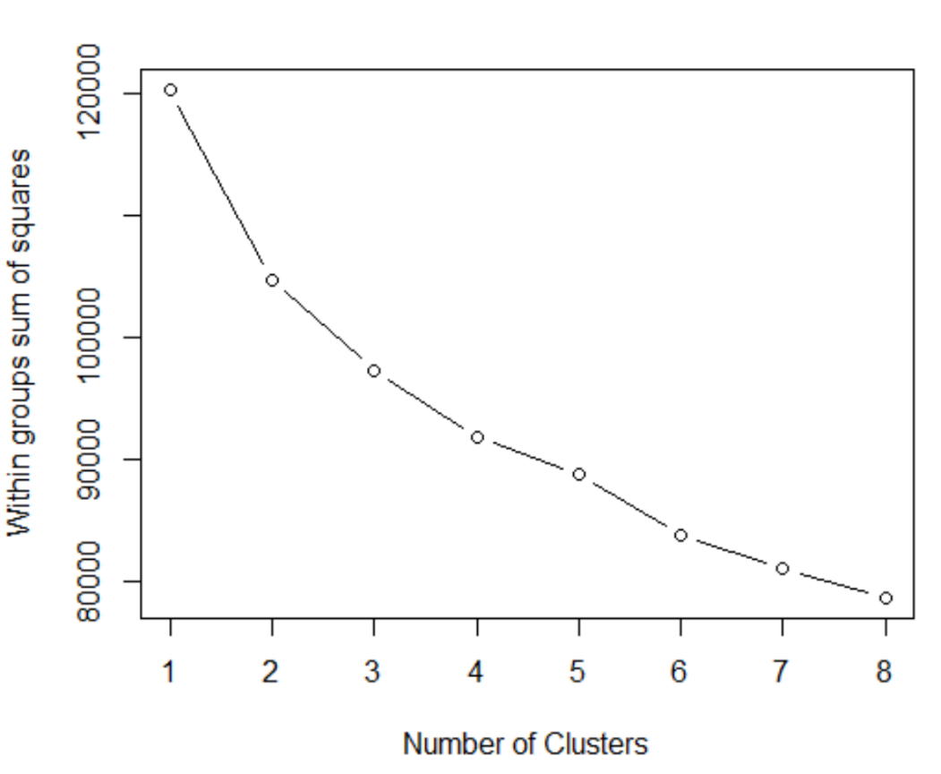

The above plot shows that the optimal number would be 4 or 5 where the line seems to have a downtick.

Keeping K=4, the K-means function is used to see the clusters. This produces a Sum of Squares Error (SSE) of 22.8%. fviz cluster plot from the package factoextra was used to visualize these clusters.

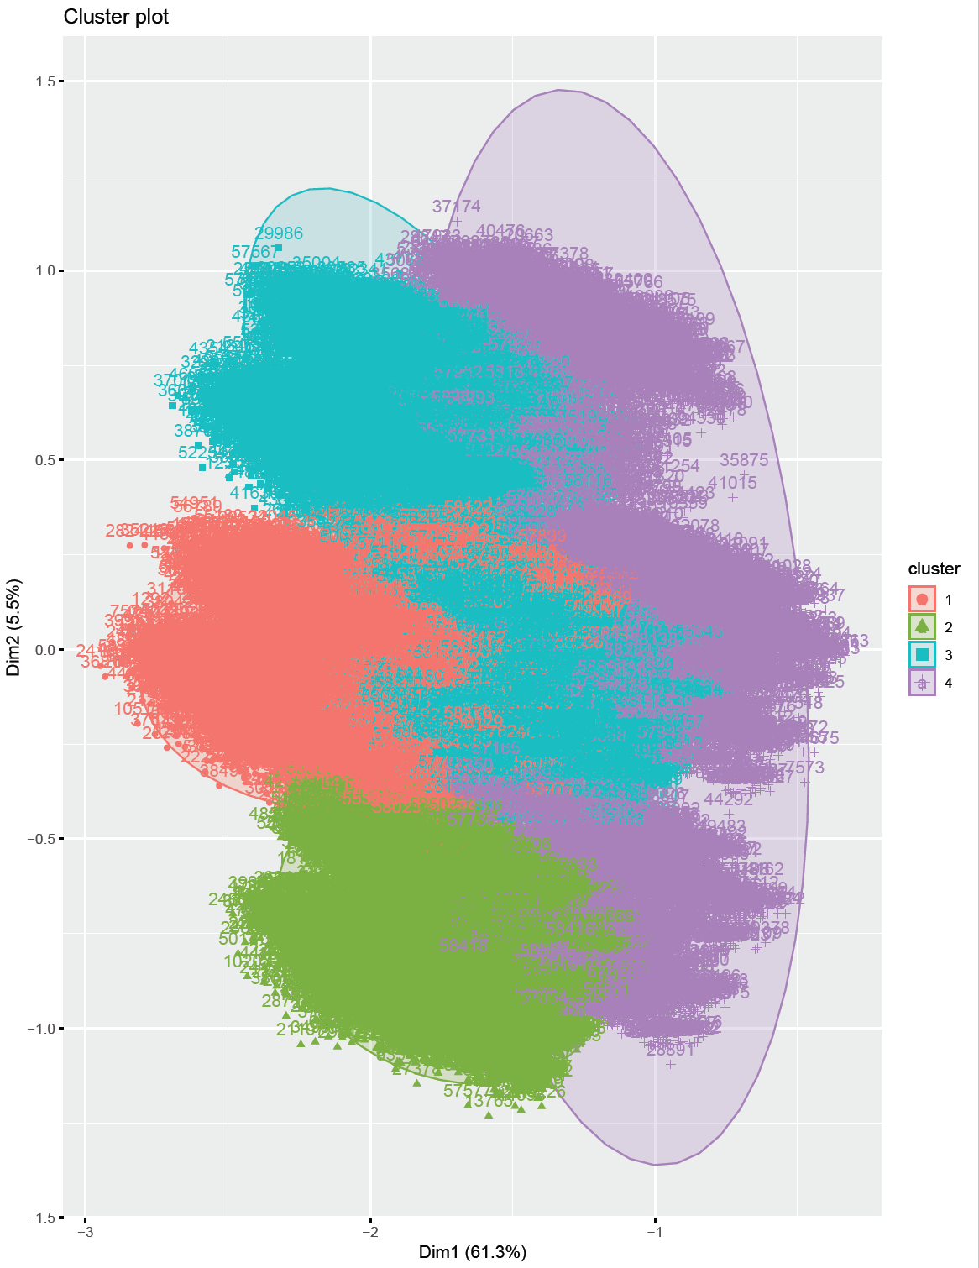

The cluster plot above is formed by using dimensionality reduction where the function combines all the variables and squeezes them into two dimensions which explains about 66.8% of the variability in the features. An inference that can be drawn from the above plot is that the patients in cluster 2 have greater similarities to one another but patients in other clusters are highly overlapping and shows that there is not enough dissimilarity between the patients to cluster them separately.

When K was set to 5, the SSE error increased to 26.4% which is not good. But the interesting thing to note here is the fact that cluster 1 is a little more separated and doesn’t have a huge overlap like it was in the previous cluster plot.

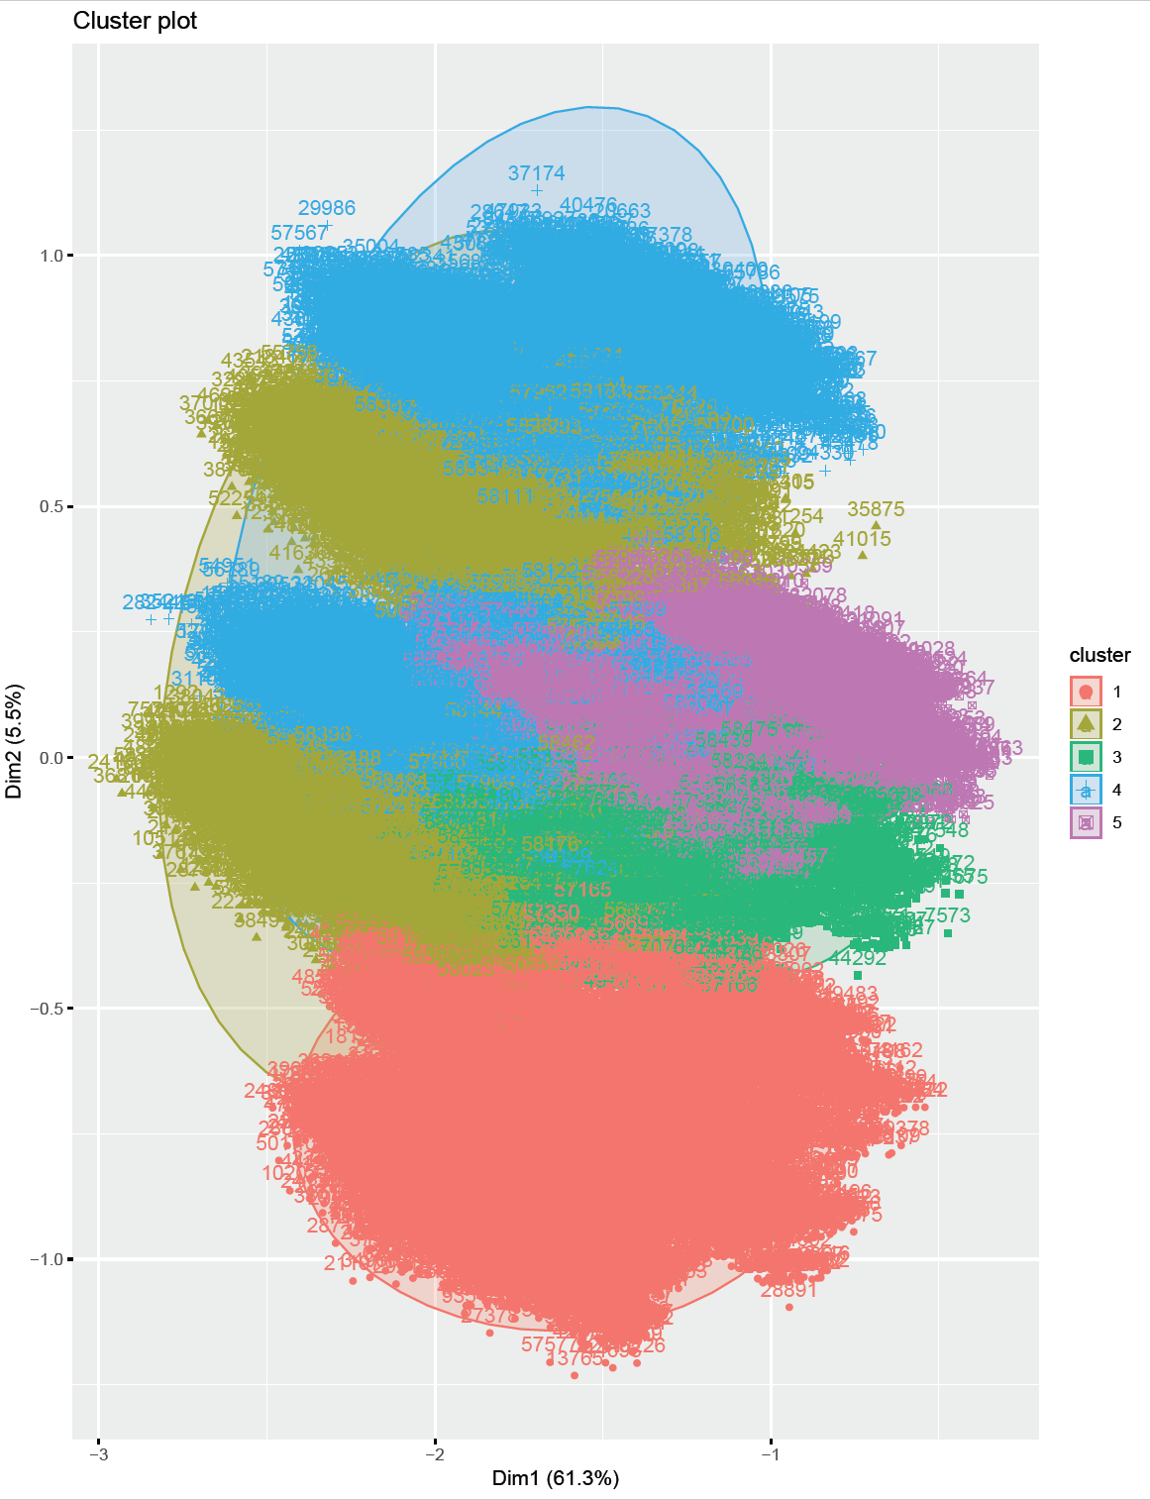

Specific variables like medical specialty and admission source id were chosen to see if that produced any better clusters. But, even here, the clusters were overlapping as seen in the below plot.

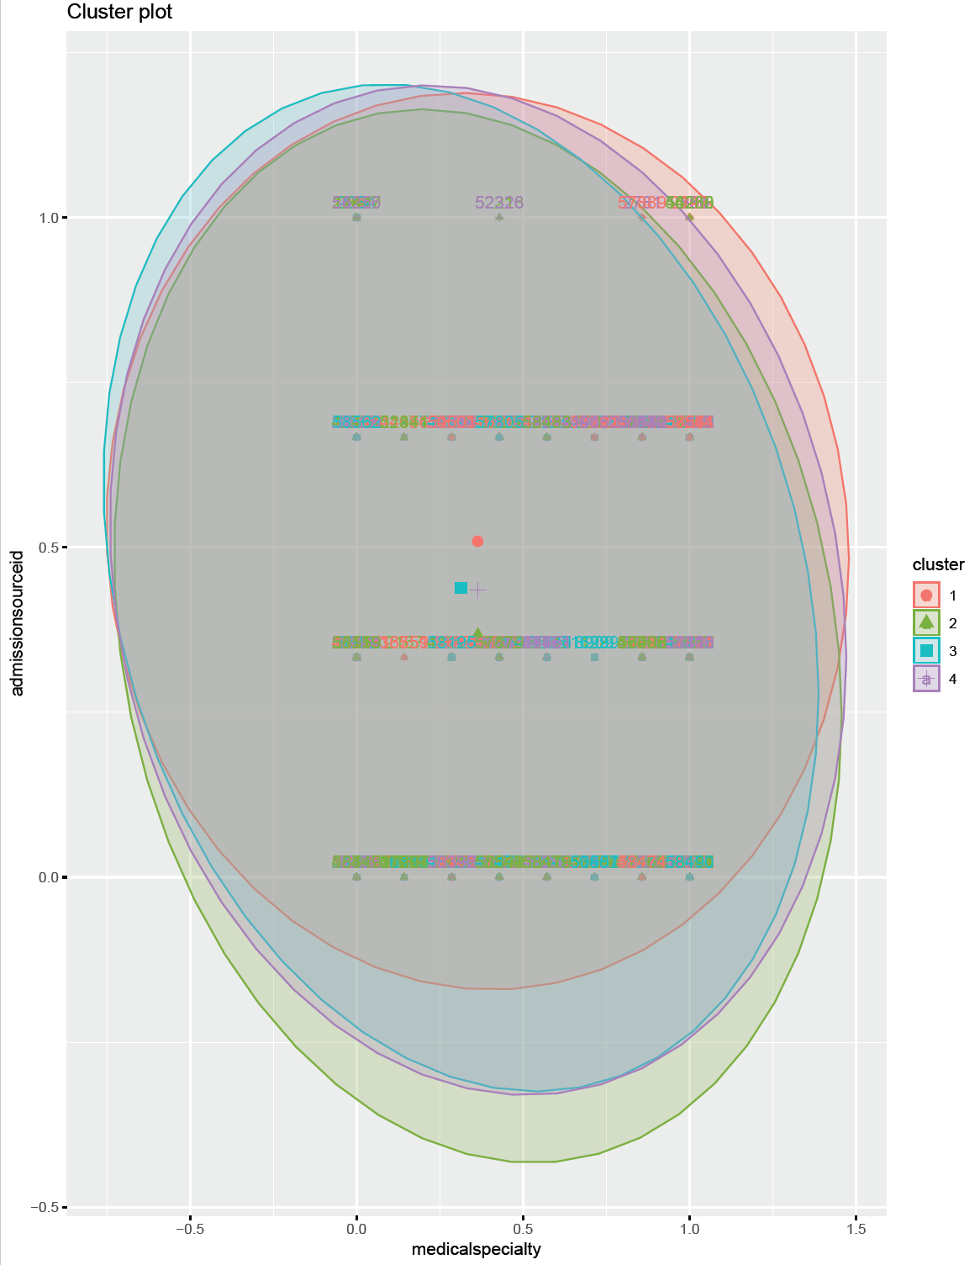

But when K was set to 5, the cluster plot that is seen below shows that clusters 2 and 3 were able to separate themselves and form identical object clusters whereas the other 3 clusters are overlapping on these two clusters.

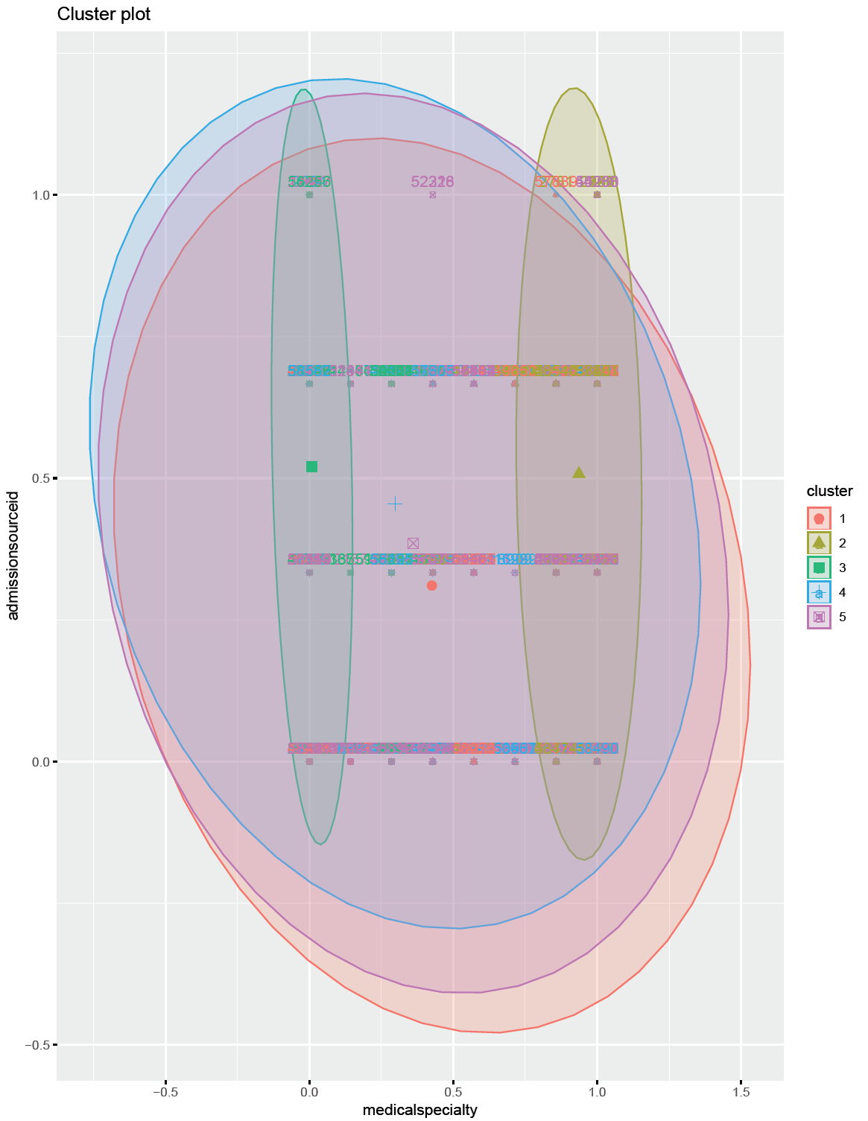

When K was reduced to 3, once again, there were two clusters formed that have considerable distance from one another but cluster 3 overlaps on the other two clusters. The resulting plot is shown below.

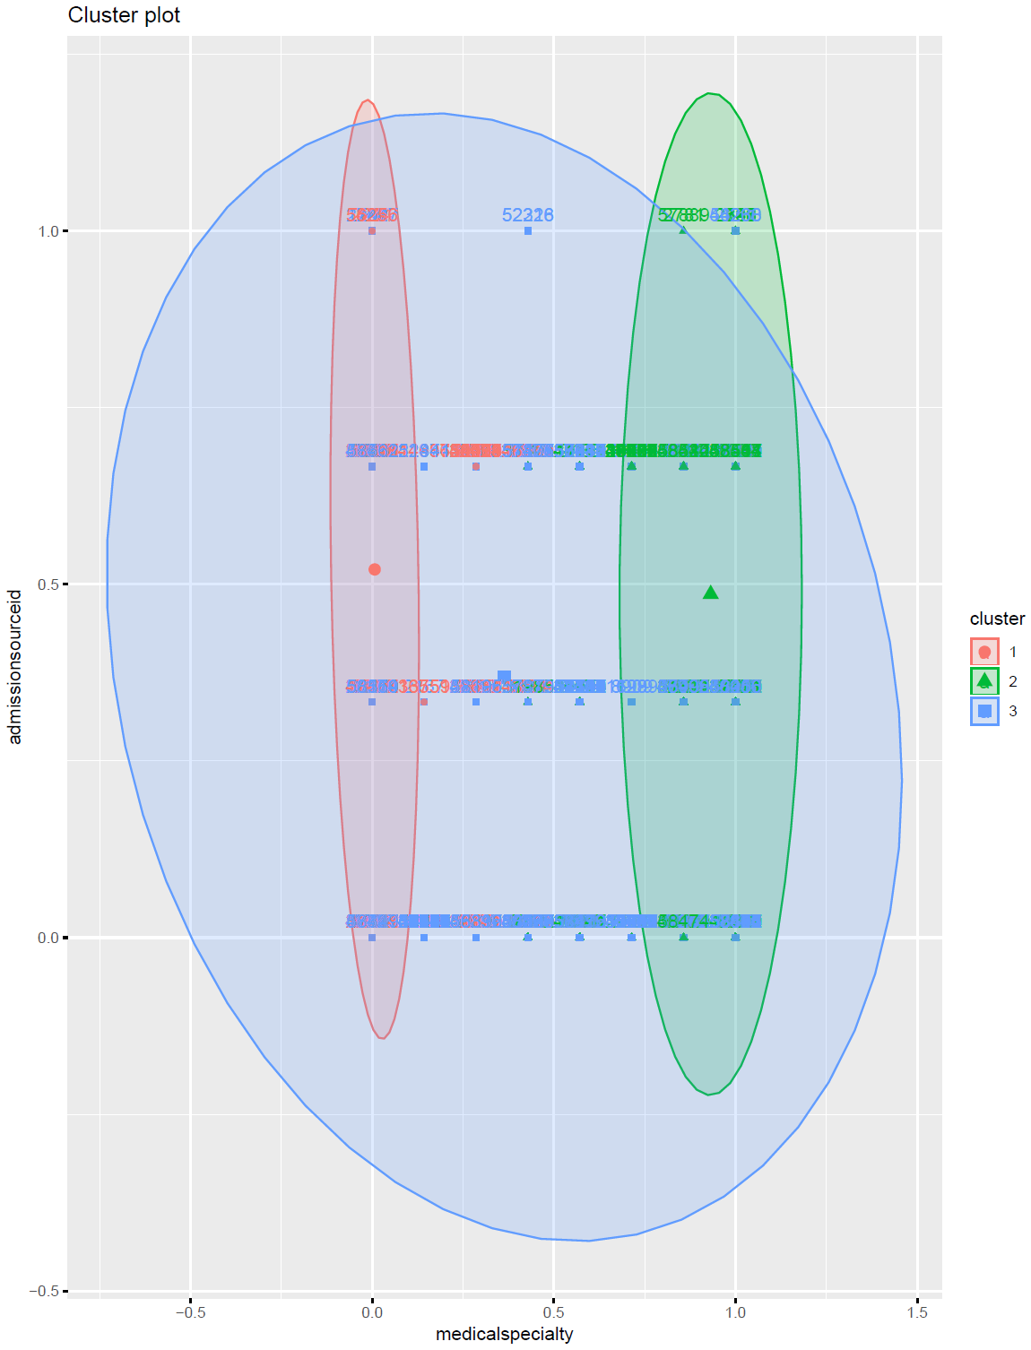

**Classification Techniques**

As per the definition provided in the book ‘Introduction to Data Mining’, classification is the task of learning a target function *f* that maps each attribute set *x* to one of the predefined class labels *y*. Classification techniques are most suited for predicting or describing datasets with binary or nominal categories. Different classification models can be built from an input data set using classification techniques. Some of the examples include decision-tree classifiers, rule-based classifiers, neural networks, support vector machines and naïve Bayes classifiers. A general approach for solving classification problems is to divide the records of a data set into a training set and a testing set. The training set is used to build the classification model, which is subsequently applied to the test set that consists of the records with unknown class labels.

**Decision Tree Algorithm**

Decision tree algorithm is a simple and widely used classification technique that has several advantages. After the model has found the patterns in the data, it shows what decisions will be made for unseen data predictions. Decision trees are intuitive and can be read by people with little experience in data mining. Basically, the algorithm starts with all the data at the root node and scans all the variables for the best one to split on. The leaf nodes or the terminal nodes are the ones with the class labels or the column name that needs to be predicted. Classifying a test dataset is straightforward once a decision tree model has been built. Starting from the root node, the test condition is applied to the test records and the appropriate branches are followed based on the outcome. This will either lead to another internal node with another variable or to a leaf node with the class label.

Once again, the dataset was processed a little differently so that the results of the decision tree can be interpreted easily instead of reading numbers on them. The column *medicalspecialty* was recoded to names and so were the columns like numprocedures, *numlabprocedures, timeinhospital, dischargedispositionid, admissionsourceid, numberoutpatient, admissiontypeid, numberinpatient, numberemergency, numberdiagnoses* and the final prediction column *readmitted*.

Two different datasets were used to generate the decision trees to see if that affected the accuracy rates. One was the normalized data set that was used in the previous technique and another is the dataset of factor datatype which has levels for every variable.

As it is required for every classification technique, the dataset was divided into train and test sets. Below is a snapshot of the number of rows present in each of the training and test sets.

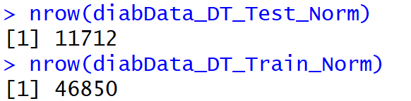

It is also very important that the labels are taken off the test set so that the predictions are not biased.

The below decision tree was created by using the normalized train dataset where the Y variable is the *readmission* column and the rest of the variables are used as the training variables to predict the readmission column. Rpart function was used with specific parameter tuning like the minimum split, minimum bucket and cost parameter to get better results.

The rpart plot is difficult to read here since it’s too big but interpreting the normal plot tree that is shown below along with the rpart plot tree helps to come to better conclusions. The plots show the conditions that were based upon for the split. As it can be seen, the number one variable that was chosen by the tree to split the data is the number of inpatient visits made by the patient. If it is less 0.024 times, the patient was classified to be readmitted and there is a 57% probability of it happening. If it is greater than 0.024 times, then the patient is classified as ‘*not readmitted’* with a 33% probability.

The next important variable that the tree takes for the split is the *age* variable where if the value is less than 0.6 times, then there is a 63% chance of the patient getting readmitted and if the age value is greater than 0.6 times, then there is a 55% chance of the patient getting readmitted. Now, since both the sides of this variable have a slightly higher chance of the same prediction, both sides are split further based on two more variables, number emergency visits and diabetes medications and so on until a final yes or no answer is received. The below plot shows that the medication variable *glyburide* is the last variable that is chosen to make the final split. It shows that if glyburide is not administered (<0.5), the patient gets readmitted and if administered, the patient doesn’t get readmitted. Roughly about 51% of the dataset was used to determine readmission of patients. The final nodes at the bottom of the decision tree are known as terminal nodes, or sometimes as leaf nodes. After all the Boolean choices have been made for a given record, they will end up in one of the leaf nodes, and the majority vote of all records in that bucket determine how the prediction for new patient records with unknown fates will be made.

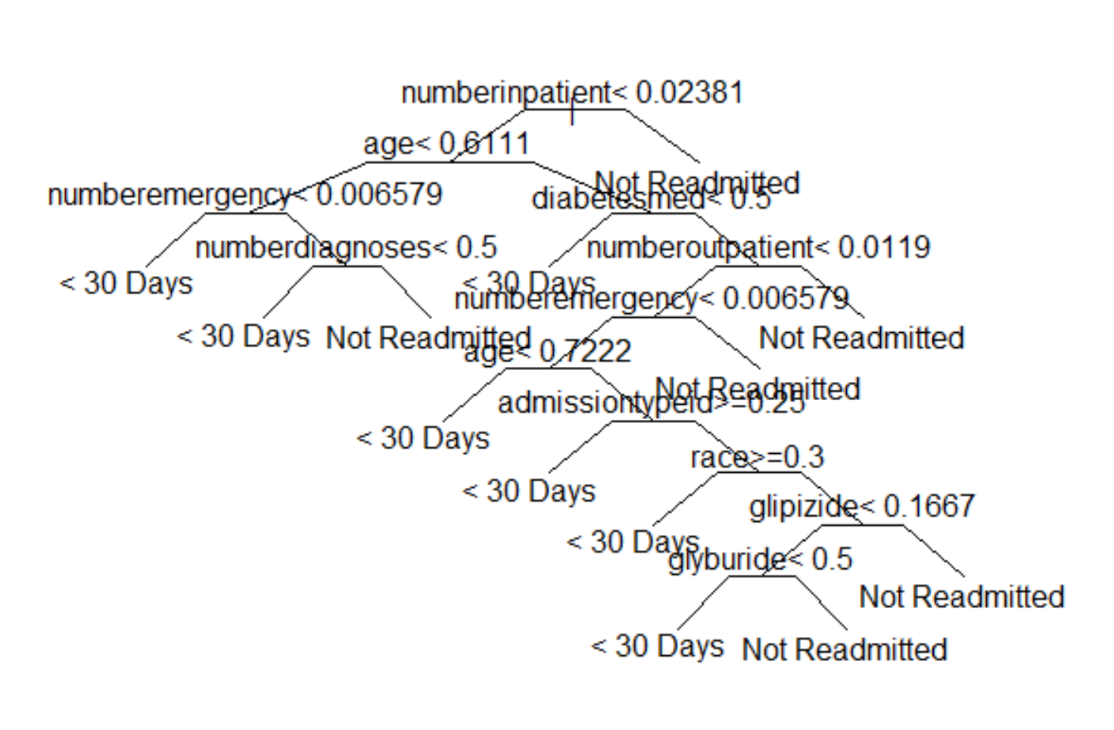

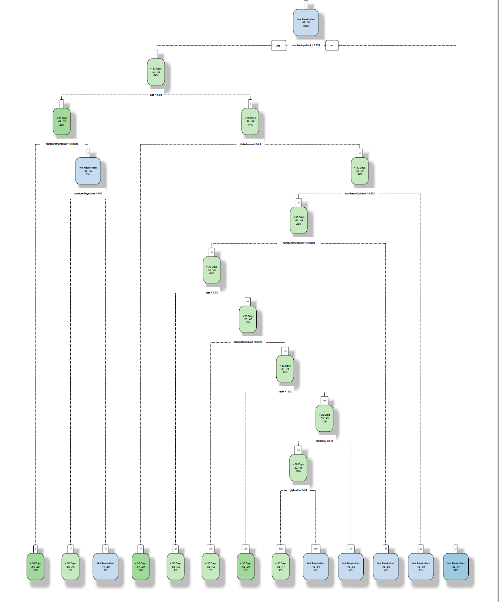

The same parameters were applied to the categorical dataset to see if it got better accuracy rates.

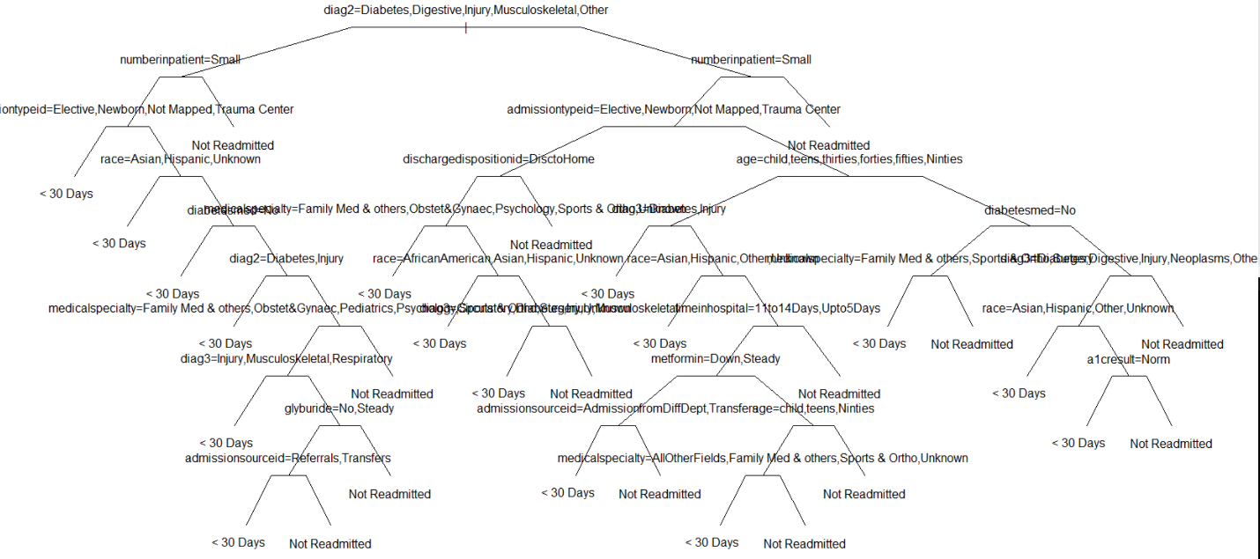

Even though this plot is easier to see the values of the attributes that were based for the split of the tree, the accuracy rates dropped to 55% and the kappa value also dropped to 0.1. Also, the attributes that were used for the split here vary from those used for the normalized dataset. Also, the balanced accuracy rate also dropped to 55% from the earlier 61% which is not good. Hence, it would be better to go forward and tune the normalized dataset to see if better results can be achieved.

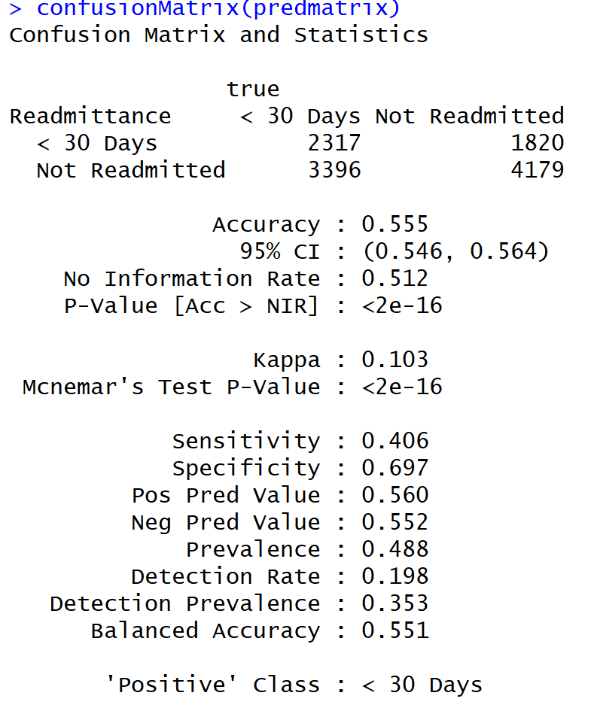

To get some more insights, user specified attributes can be fed into the model as x values for different analysis and trees. On the normalized dataset, different variables were chosen as the X variables by keeping the Y variable as the constant *readmitted* column to see if better accuracies can be achieved. No matter what variables were chosen, the tree always chose the variable *numberinpatient* as the primary variable to do the split irrespective of how many splits, buckets or cost parameters were chosen. The accuracy rate went down when this variable number inpatient was taken out. The highest accuracy achieved is 61% but a pruned decision tree was obtained. The below tree shows that when the *numberinpatient* variables is less than 0.024 times, the patient is classified as readmitted with 57% probability and classified as ‘not readmitted’ with 33% probability.

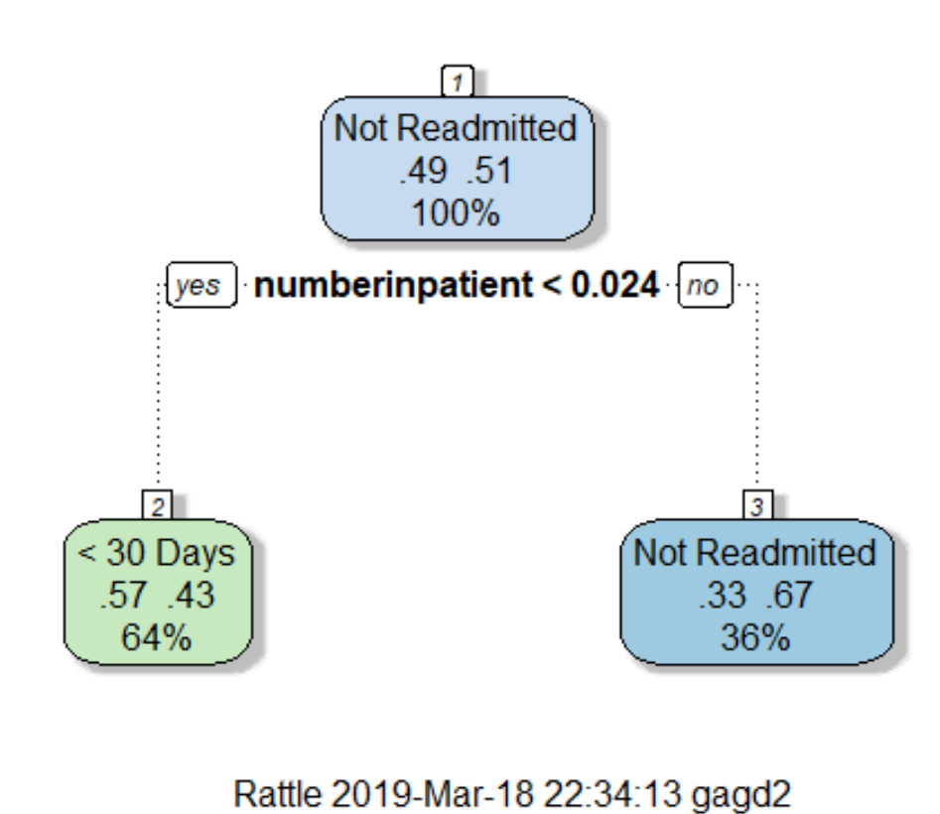

Splitting rules can be constructed in many ways, all of which are based on the notion of *impurity- a* measure of the degree of heterogeneity of the leaf nodes. Put another way, a leaf node that contains a single class is homogeneous and has impurity=0. There are three popular impurity quantification methods: Entropy (aka information gain), Gini Index and Gain Ratio.

The first model and tree that was built showed that the node was split using the variable *‘numberinpatient’.* Why did the model select this attribute to split and classify the label? When the Gini index method was used to calculate the indexes, the variable *‘numberinpatient’* had the maximum value of 0.5 which made the model choose this variable. The below screenshot shows the Gini index values of all the attributes.

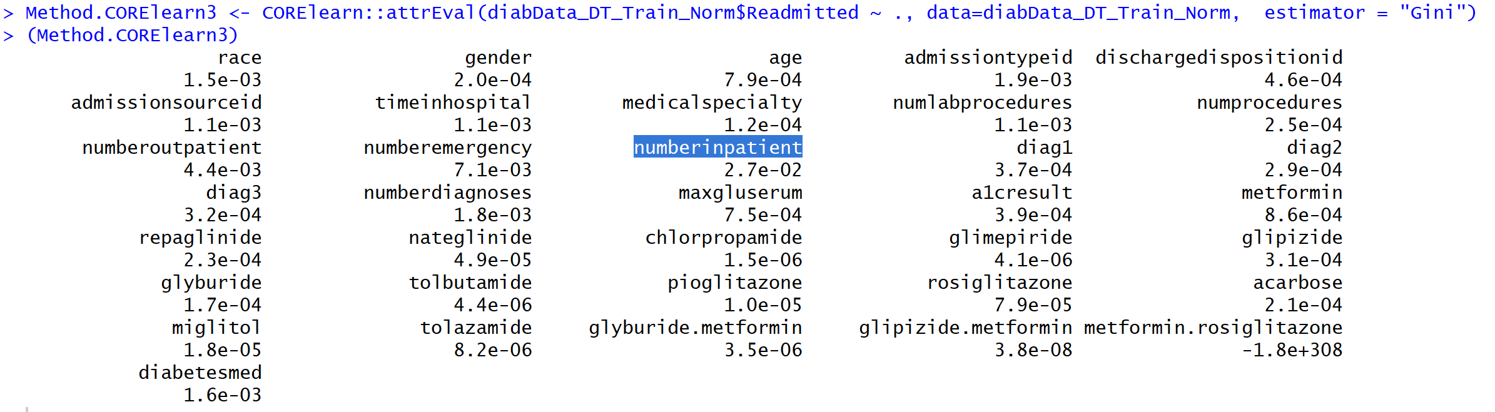

Another way to determine the goodness of a split is to calculate the information gain. Comparing the degree of impurity of the parent node before splitting with the degree of impurity of the child nodes after splitting, the performance of the model can be evaluated. The larger the difference the better the model. The below screenshot shows the information gain values of all the attributes in our dataset. Variable *‘numberinpatients’* once again has the highest information gain value of 1.

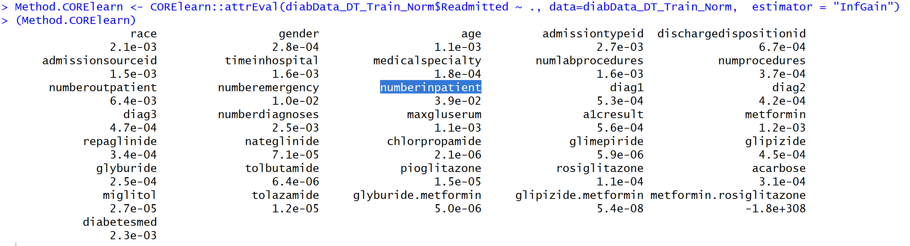

**Naïve Bayes Classifier Algorithm**

Naive Bayes is a classification algorithm for binary (two-class) and multi-class classification problems. The technique is easiest to understand when described using binary or categorical input values. It is called naive Bayes because the calculation of the probabilities for each hypothesis are simplified to make their calculation tractable. Rather than attempting to calculate the values of each attribute value, they are assumed to be conditionally independent given the target value. This is a very strong assumption that is most unlikely in real data, i.e. that the attributes do not interact. Nevertheless, the approach performs surprisingly well on data where this assumption does not hold.

The normalized dataset that was used for the decision tree generation is used for this algorithm as well. The naiveBayes function from e1071 package was used to train the training dataset. First, the model was trained using all the variables as X variables and keeping the *readmitted* column as the Y variable. Once the model was trained, it was used on the test dataset to predict the *readmission* column. An accuracy of 60% was achieved on the predictions.

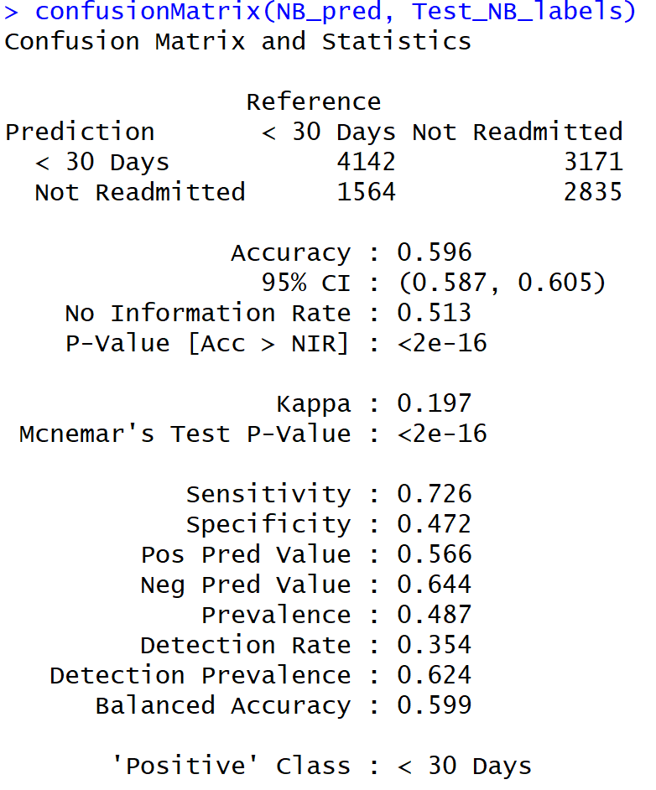

Next, the function InfoGainAttributeEval was used to filter out those attributes with the highest information gain and these variables are selected for the next model to see if better prediction accuracy rates can be achieved. The below bar plot shows the variables with the information gain values where *numberinpatient, numemergency and numoutpatient* variables have the highest information gain. Using just these variables, another naïve Bayes model was built using the normalized training dataset.

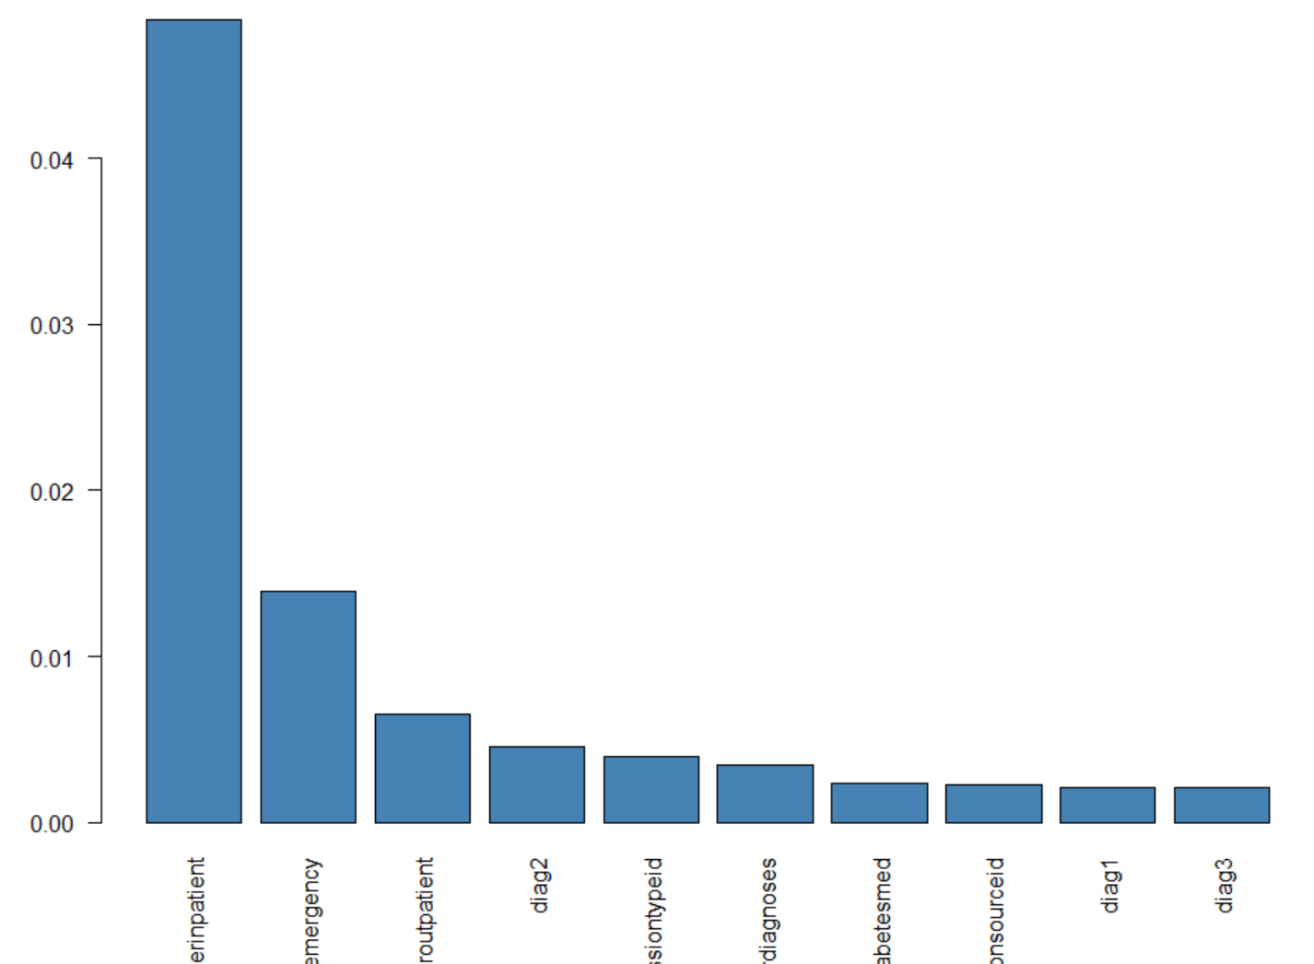

A different function from the klaR package was also used to see if accuracy rates will go up. But that didn’t provide any better result either. In fact, the accuracy rates went further down to 55%.

Also, some density plots were generated using the NB model to understand the effect of the variables on the model. Below are the different plots for each of the variables.

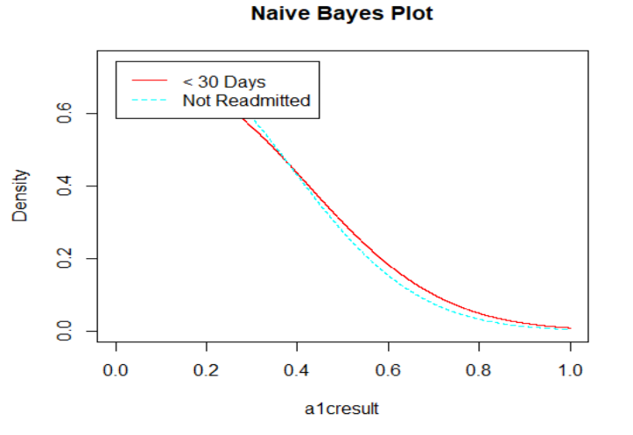 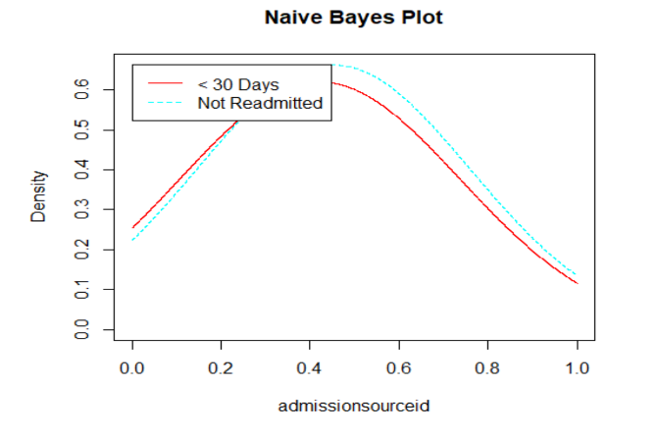

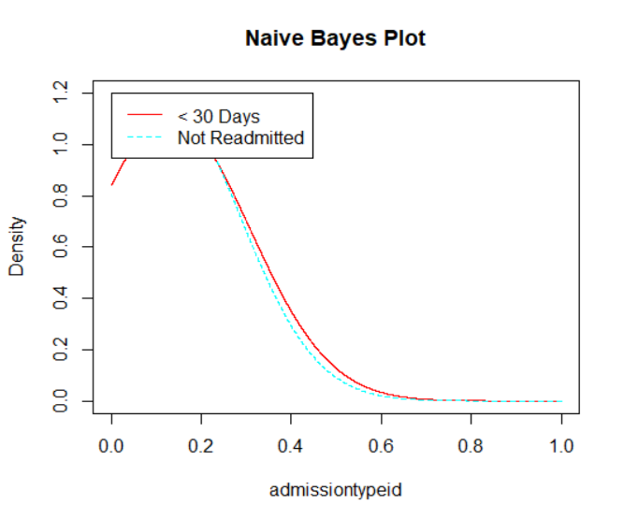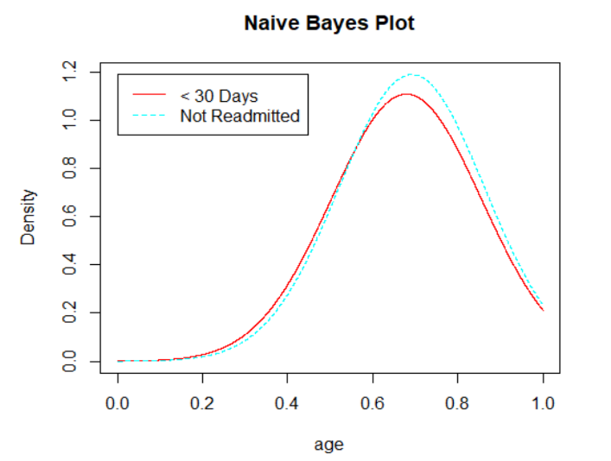

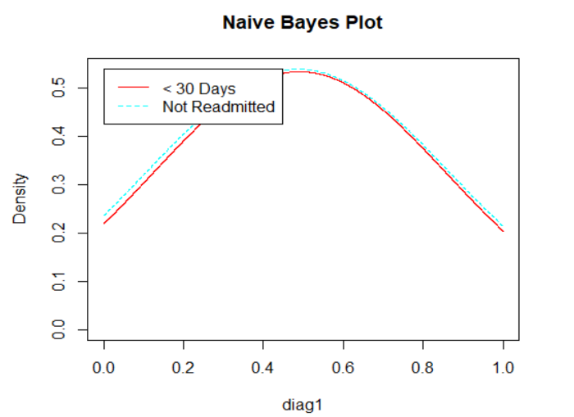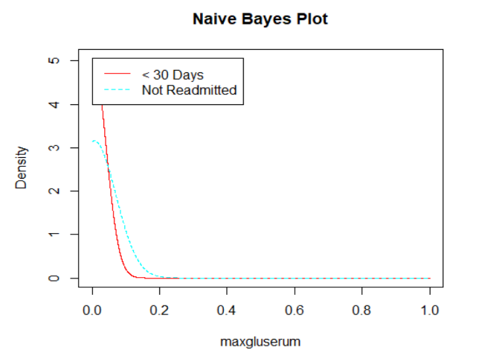

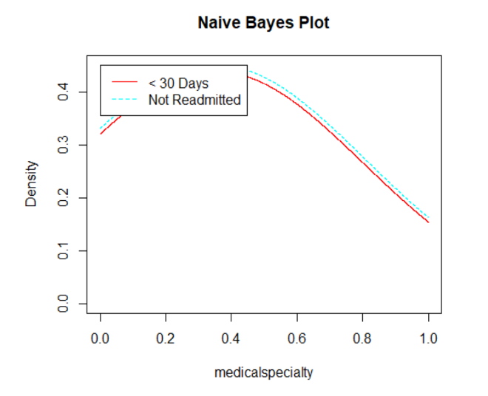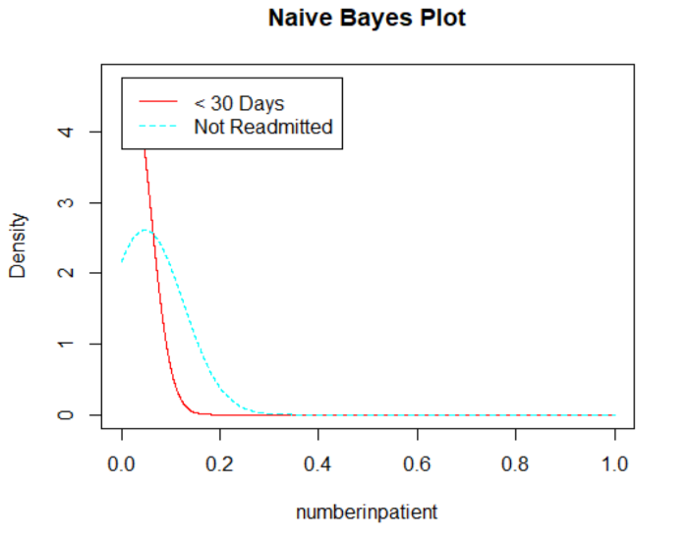

**Support Vector Machine Algorithm**

Support Vector Machine abbreviated as SVM is a simple algorithm that is highly preferred as it produces significant accuracy with less computation power. The objective of the SVM algorithm is to find a hyperplane in an N-dimensional space that distinctly classifies the data points. There are many possible hyperplanes that can be chosen to separate two classes of data points. To classify data points with more confidence, the margin distance should be maximized. Also, the dimension of the hyperplane depends upon the number of features. If the number of input features is 2, then the hyperplane is just a line. If the number of input features is 3, then the hyperplane becomes a two-dimensional plane. It becomes difficult to imagine when the number of features exceeds 3. Support vectors are data points that are closer to the hyperplane and influence the position and orientation of the hyperplane. Using these support vectors, we maximize the margin of the classifier. Deleting the support vectors will change the position of the hyperplane. These are the points that help us build our SVM.

The SVM model was applied to the same normalized training data that was used for the previous two classification techniques. Different parameters were tuned to predict the readmission rates. First, the polynomial kernel was used with a cost of 0.1 and the model was trained. This model was used on the test dataset to predict the class labels and a confusion matrix was calculated. The misclassification error rates were also calculated. Below are the results.

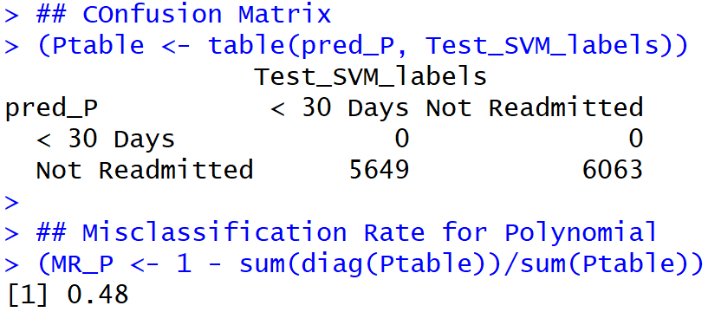

This kernel produced a high misclassification rate of 48% which is not useful at all.

Next, the parameter was tuned to use the linear kernel with the same cost and the misclassification rates were calculated again. Now, the misclassification rate went down to 40% which is better than the previous kernel results.

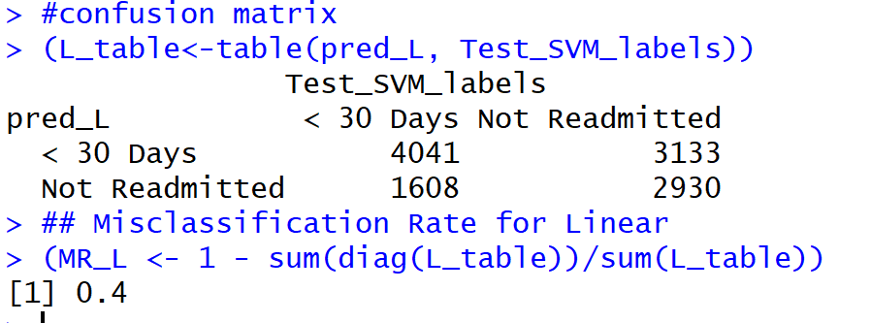

The parameters were once again tuned to use the radial kernel at the same cost to predict the readmission rates. The misclassification error rate is 43% and it performed better than the polynomial kernel but is not as good as the linear kernel.

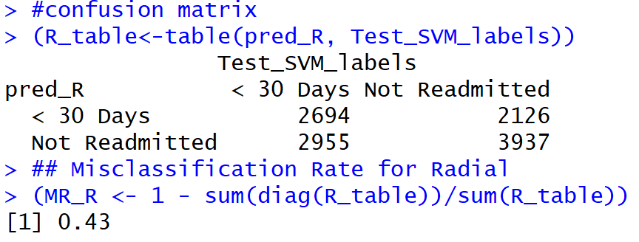

**Text Mining**

Text algorithms allow analysts to extract useful insights from raw text, which is useful when a dataset has information in the form of notes or descriptions from doctor visits or loan applications. With text mining, analysts can identify which words or phrases in raw text are associated with certain outcomes, giving them greater insight into the factors that relate to their target variable, or object of analysis. Text mining is important because text data is ubiquitous in every industry. Medical examination notes, customer reviews of doctors and hospital services contain some vital information for predicting future events but are rarely formally structured. Text mining allows analysts to make the most of this data, leading to more practical models with higher accuracy.

To describe this process and how it can be effectively used in the field of medicine and make patients satisfied, some patient reviews of various hospitals in the U.S were pulled into an excel file and used for further analysis. For this analysis, a common text mining algorithm called Sentiment analysis is used to predict if a review is a positive and negative feedback. There are two columns and 30 rows in this dataset. Now, the challenge with this dataset is the fact that the reviews are spread across multiple columns and is not clubbed in a single column. So, lots of cleaning and pre-processing is to be done on this data before analyzing it.

First, the sentiment label is separated from the dataset and stored in a separate variable. Then, the *unite* function from *tidyr* package is used to unite\merge the different columns of the texts into a single column called *review.*

To analyze text data, one of the most important concepts that must be applied is to get the data into a matrix format where the rows are the different reviews and the columns are the words and the frequencies of these words in each review make the values inside this matrix. In order to accomplish this, first, the words are tokenized, and unnecessary numbers, punctuations, hyphens and symbols are removed from the text. All the words are also converted into lower case and English stop words are also removed.

The next step is stemming the document. In linguistics, stemming is the process of reducing inflected (or derived) words to their word stem, base or root form-generally a written word form. The SnowballC package is used for document stemming. For example, “complicated”, “complication” and “complicate” will be reduced to “complicat” after stemming. This is to ensure that the same word is not repeated as multiple versions in the TDM, and we only have the root of the word represented in the TDM. *Tokens_ngram* function was also used to separate the words into single and bi-gram words. The tokens are now converted to a document frequency matrix and treated for sparsity.

Some exploratory data analysis was done to see the most frequent words in this data. The below bar plot shows the same where the words ***care, place, wait, go, doctor, need***are the most frequently used words.

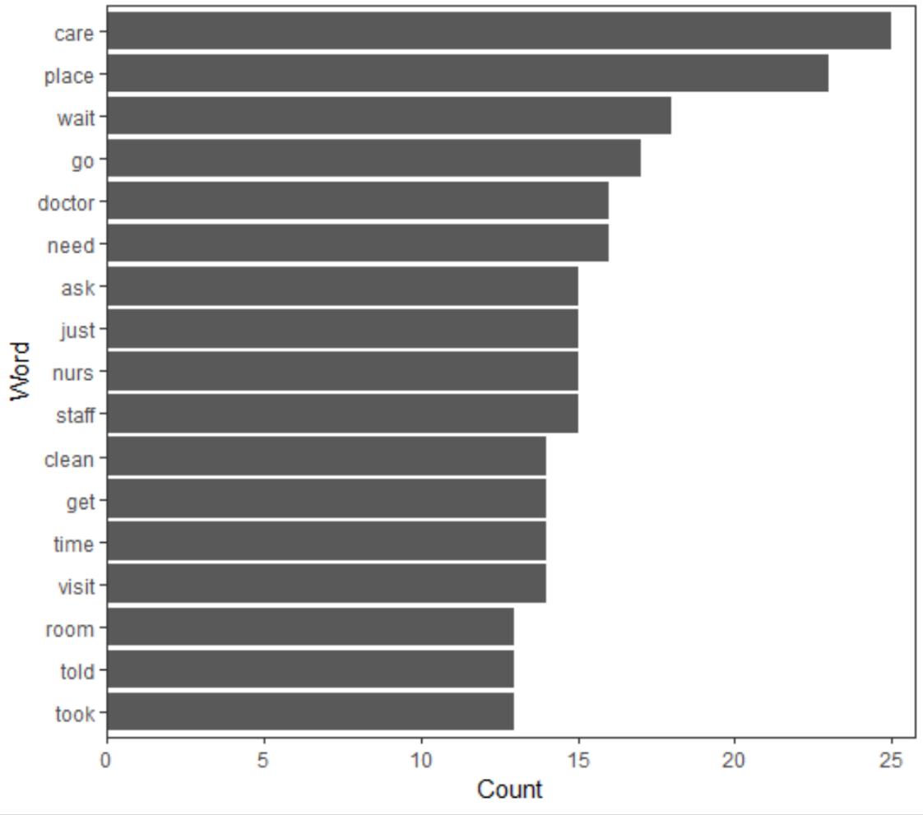

A quick word cloud function usage also shows the words that are most frequently used and the ones that are less frequently used at the same time. One can see that some words like ***feel, star*** are less frequently used.

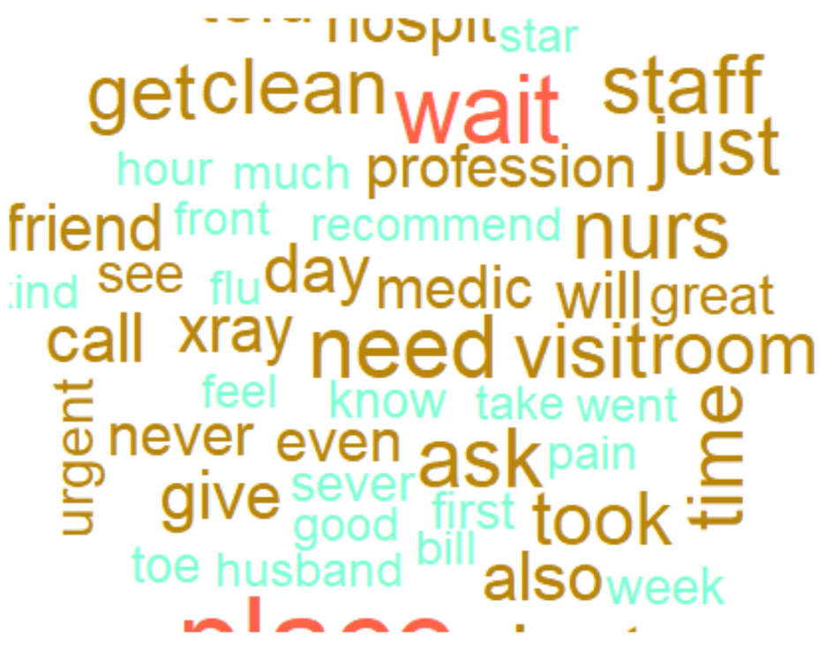

The label ‘Sentiment’ is added back to this cleaned and pre-processed data to run classification models. As usual, the dataset is divided into train and test datasets and the test dataset is stripped off labels. The below output shows that the test data has 10 rows and the train data has 20 rows after sampling.

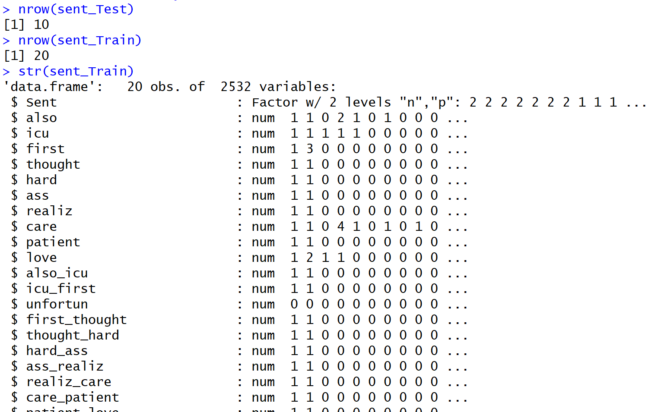

Below is a screenshot of the dataset with sentiment labels that is going to be used for classification model building.

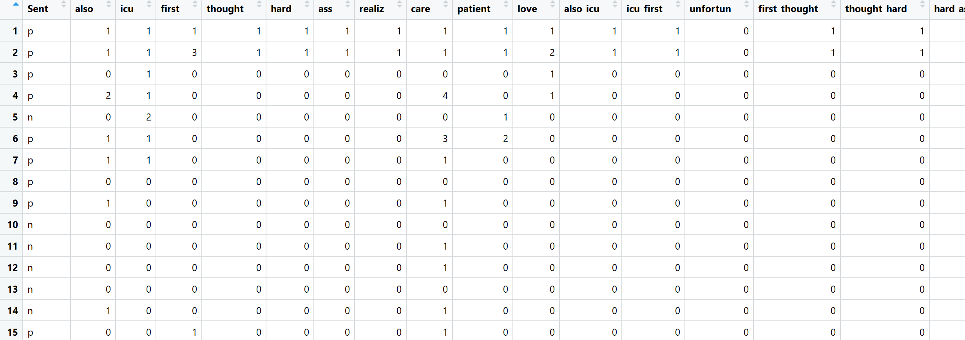

For this review dataset, the naive Bayes function from the library e1071 package is used by holding the label which in this case is the column ***Sent*** as the Y variable and use all other words in the training data to create a model. This model is then used to predict the labels of the test data. The results are then compared with the labels of the test data that we have stored in a separate variable.

To tune the parameters of the model, **InfoGainAttributeEval** function was used to evaluate the variables or words that contribute the most to the label. A quick bar plot visualization shows the top words with the highest information gain.

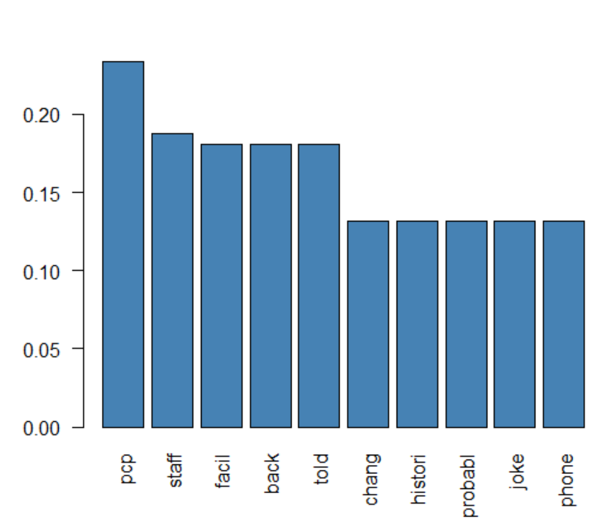

Using the top three words from the bar plot, a second model was built which produced an accuracy rate of 70%.

Now, moving on to building the **SVM model** on the sentiment dataset to see if it obtains better results.

All three different kernels such as the linear, polynomial and radial kernels were used on the lie dataset and misclassification rates were calculated. The cost was kept at 0.01.

The below bar plot shows that the linear kernel gave the least misclassification rates with a rate of 50% and the polynomial and radial kernel models had the highest error rate of 60%. Thus, the SVM models with linear kernels were chosen as the best SVM models for this dataset.

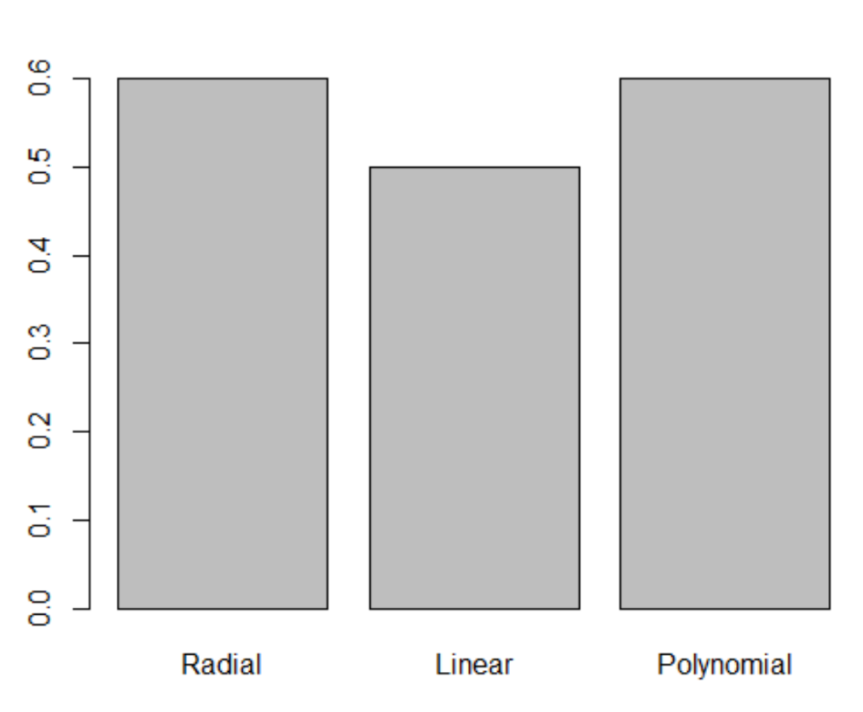

However, the NB model performed better with 70% accuracy rate in predicting the sentiments of the patient reviews on the doctors\hospitals than the SVM models.

**Results**

The accuracy rates and error rates of all the different techniques are discussed below. The different strategies employed gave better results from each model.

**Association Rule Mining**

Some of the interesting results obtained from this technique is the fact that there is a connection with symptoms related to Neoplasms diseases and symptoms of diabetic patients that could lead to readmissions? Is one masking the other? Or could there be a relation between the two? This is something to ponder about. Also, the fact that there is a 79% probability of readmission for patients who were not ordered glucose serum tests raises concerns and urges doctors in hospitals to order this test as the first precautionary test for diabetic patients to reduce readmission rates.Another concern that is to be raised to hospitals is the fact that most of these readmissions happen to patients who were transferred from other hospitals. What is the cause for this?

On the other hand, it looks like the physicians from the Ob&G department are well equipped or trained to detect the needs of a diabetic patient OR the fact that they mandatorily check and order the required glucose test results for their patients as part of their department procedure seems to help reduce readmission rates of patients. It would also be interesting to remove all these patient records admitted by Ob&G physicians and rerun the analysis to see how it affects the results.

Looking at the rules associated with readmissions greater than 30 days, majority of the factors that contributed to the readmission is the patient being diagnosed with respiratory illness and whose glucose serum levels were greater than 300. Why were necessary medications that could have prevented the readmission not administered to the patients? Also, something else contributed to delaying the readmissions to more than 30 days. Speaking to medical professionals about this will give more insight into the problem.

**Scatter Plot for Rules – Readmitted=1(patients readmitted in less than 30 days)**

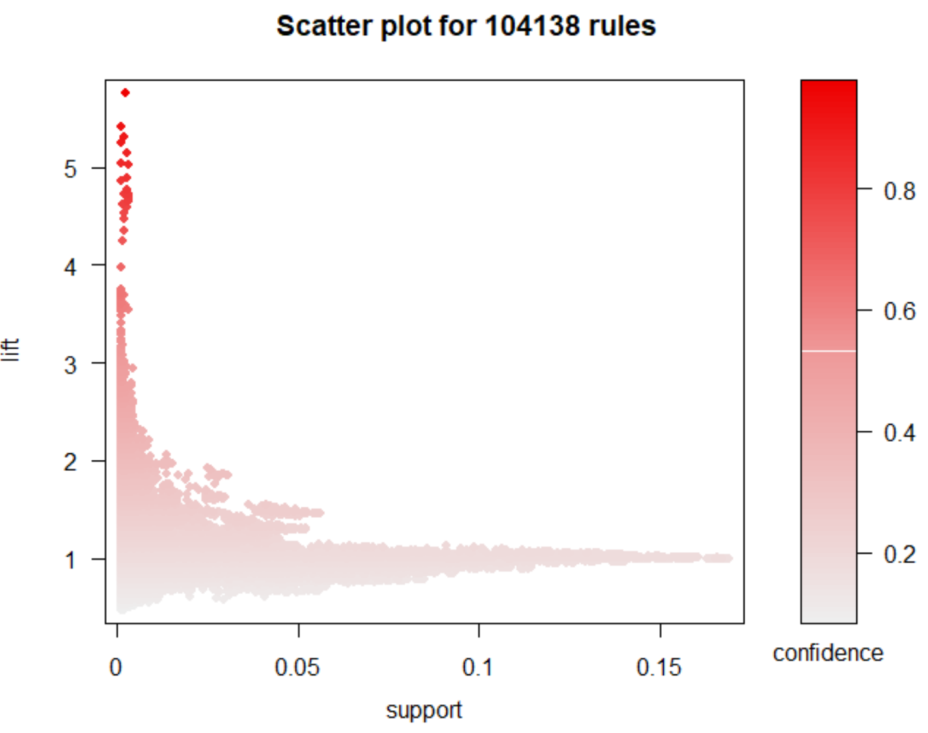

The above scatter plot shows that there are only a few interesting rules with low support but a lot of rules with high lift and confidence that needs to be concentrated upon.

**Scatter Plot for Rules – Readmitted=0(patients not readmitted)**

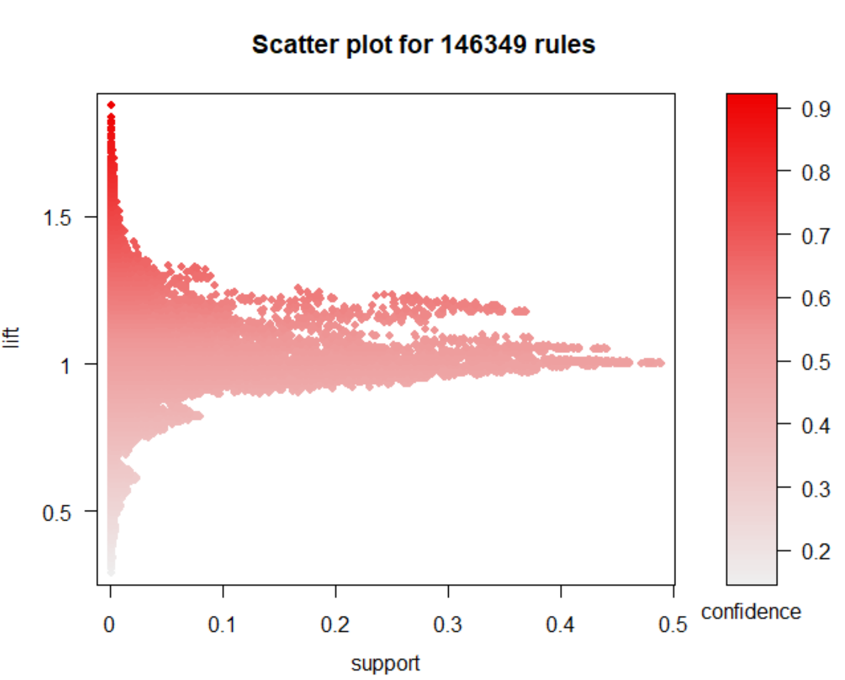

Here, a greater number of rules have a high lift and low support showing the many factors that can contribute to ‘no readmissions’.

**Scatter Plot for Rules – Readmitted=2(patients readmitted greater than 30 days)**

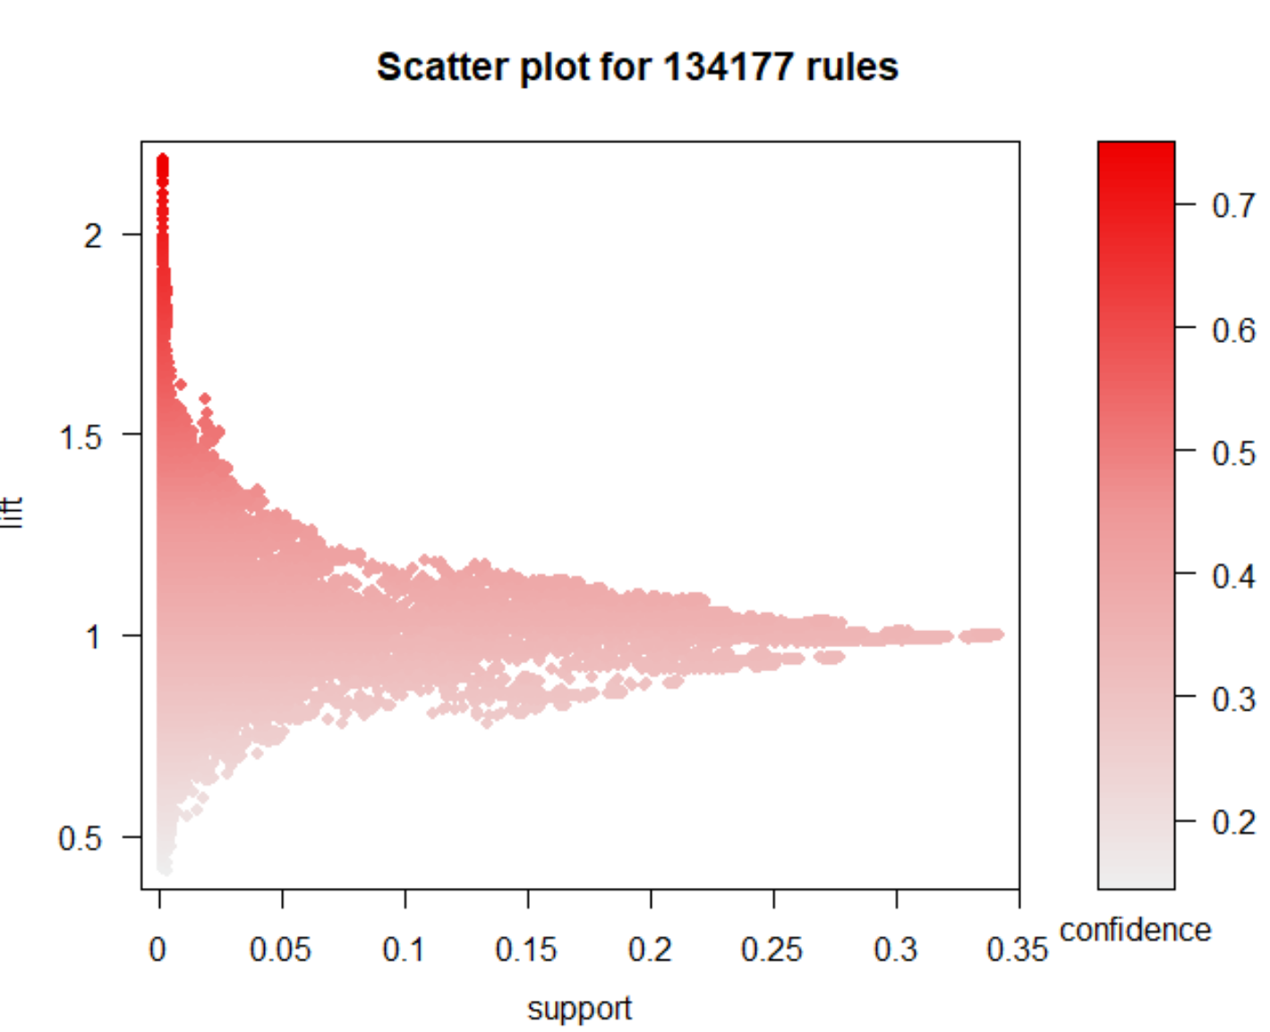

This plot is quite like the previous plot showing more rules with high lift and ones with low support.

Altogether, the ARM technique has been able to associate and filter out many important and interesting rules to draw inferences and take actions on.

**Clustering – K-Means**

Clustering using K-means algorithm did not really provide a good differentiation of the patients using PCA. When K=5 or 4, the clusters are overlapping showing that there are too many common features between the patients. This is probably because of the imbalance in the dataset which has more information on the patients who were not readmitted than the ones who were. Hence, it is to be concluded that the clustering should be performed on a more balanced dataset to understand the results.

**Decision Tree Algorithm**

The decision tree algorithm gave some interesting insights into what is that one important variable that leads to readmission of a patient and that is the ‘***numberinpatient****’* variable. When the number of inpatient visits in the year preceding the encounter was 0, the patient had a very high probability of not getting readmitted. Otherwise, when the patient had made inpatient visits the same year before the encounter, the chances of readmission were higher.

A confusion matrix function was used to find the accuracy rate of the first decision tree that was built based on all the variables in the dataset and it came up to 61% with a kappa of 0.22.

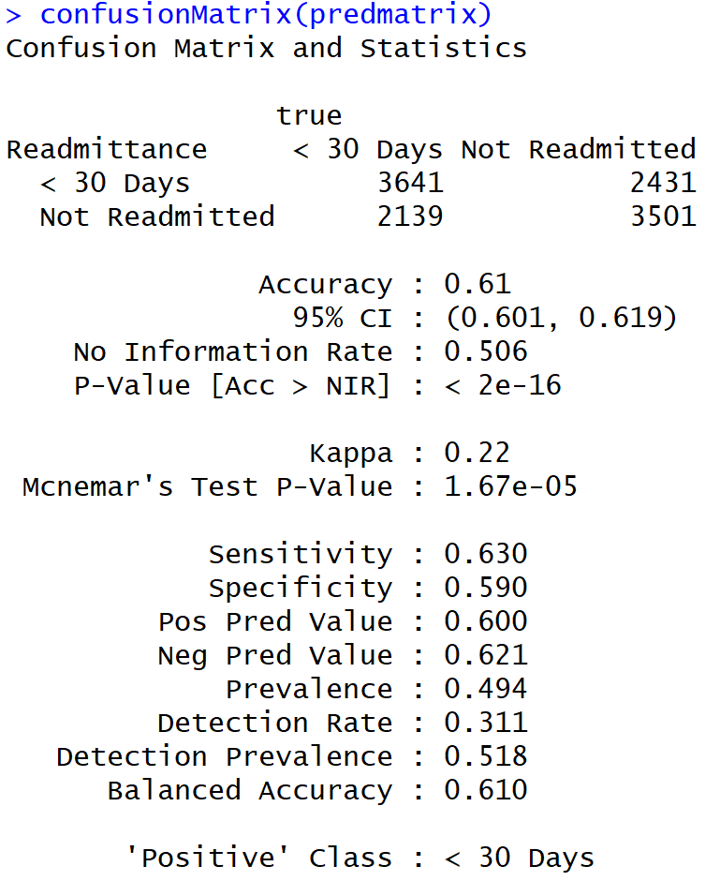

It could also be concluded that even though using a categorical dataset helps to read the decision tree a little better, it did not come up with good accuracy rates. The accuracy rate went down to 55% from the 60% rate that was produced using the normalized dataset.

Also, pruning the dataset with fewer variables or trying different cost parameters or splits always brought the same answer where ***numberinpatient*** variable was the variable used for the primary split and the accuracy remained the same.

**Naïve Bayes Algorithm**

The below quadrant plot shows the intensity of the predictions of the first model that was built with all variables. It is easier to comprehend and say that the model was able to predict more accurate records of readmission than inaccurate records. But, the accuracy and inaccuracy of predicting the ‘no readmission’ rates are almost equal, and it must be improved.

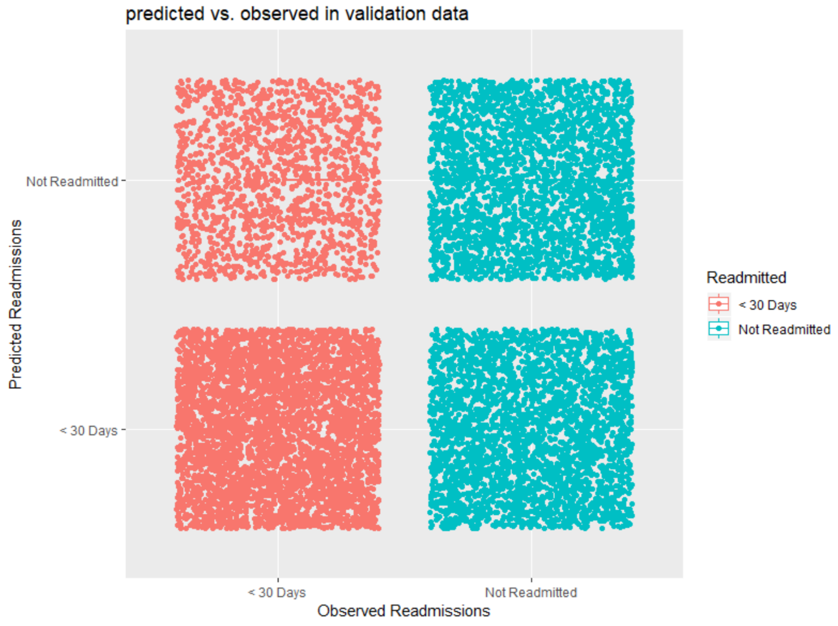

Reducing the number of variables used to train the model did not improve the accuracy rates. The accuracy rate came down to 57% which is not any better than the previous model. Even selecting the ***numberinpatient*** variable as the main variable didn’t improve the results.

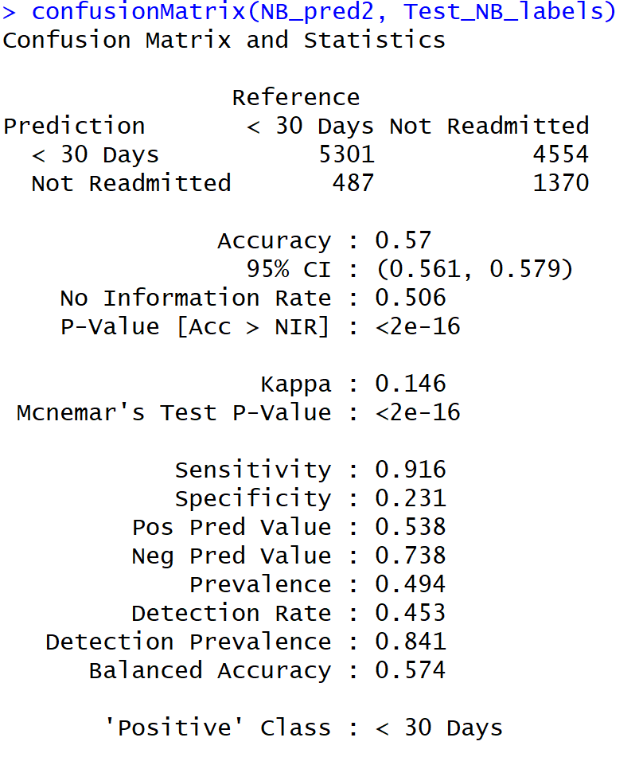

**Support Vector Machine Algorithm**

The below plot shows the prediction rates of the SVM model with linear kernel and using all the variables as input. Even though a 60% accuracy rate is not that great, this is still better and useful than the models trained with the other two kernels. Just like the NB model, the SVM model also was able to predict a greater number of accurate predictions for the readmissions than the ‘no readmission’ rates.

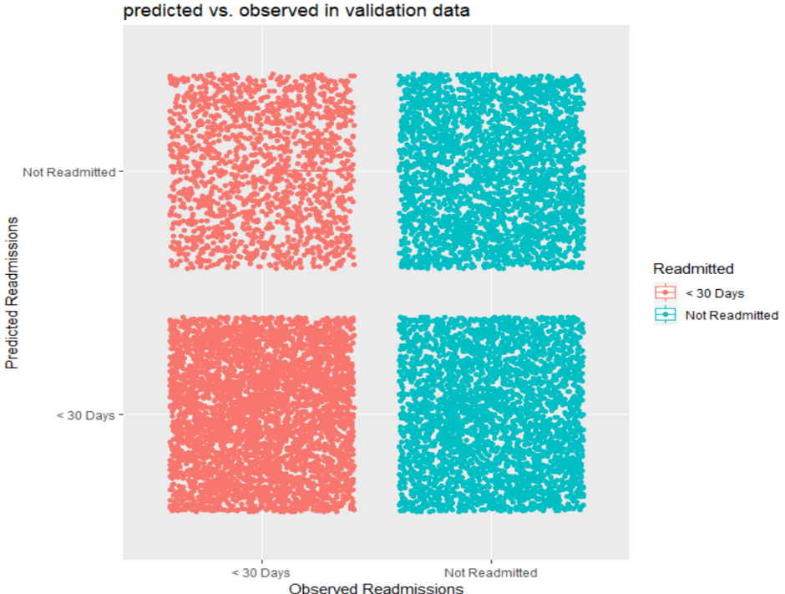

**Text Mining**

Both SVM and NB models were used for text mining. For the Naïve Bayes model, a confusion matrix on these predictions show an accuracy rate of 60%.

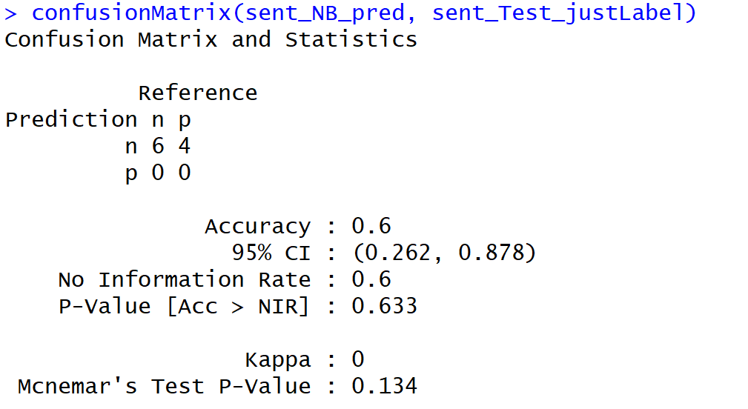

Below snapshot shows the confusion matrix of the NB model with only the top three important words in the reviews. This resulted in an accuracy rate of 70% which is a good step up.

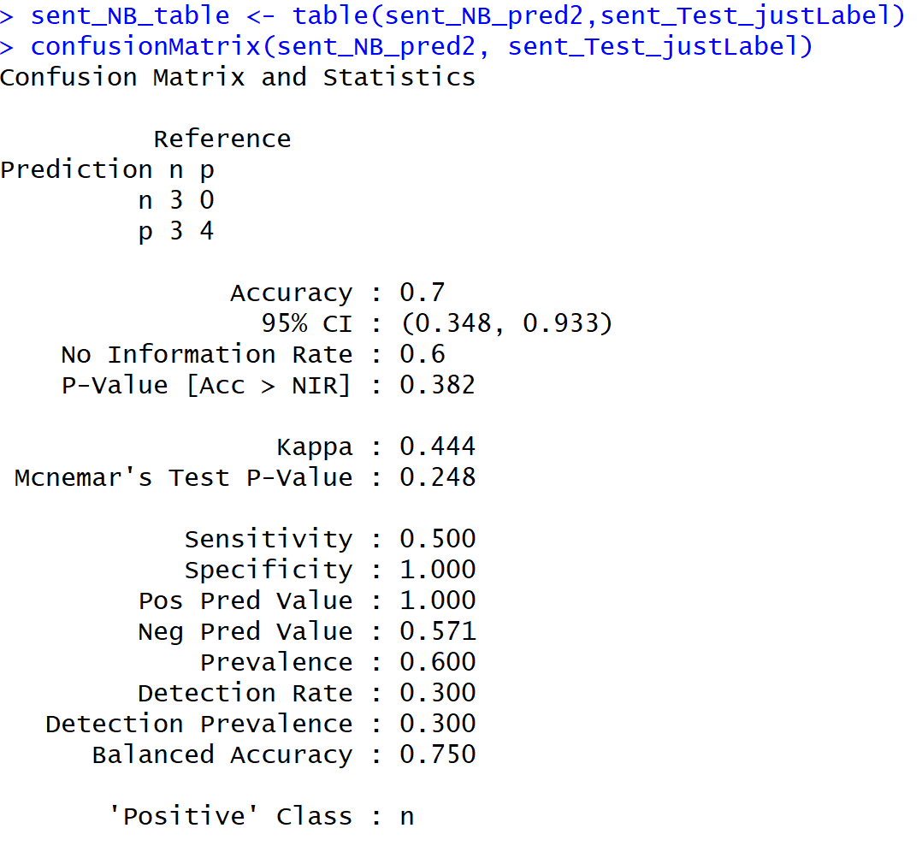

Using the SVM model, the accuracy rate was only 50%. Hence, overall the NB model performed very well on the text data to predict the sentiments of the reviews.

Altogether, the decision tree algorithm and the ARM techniques were able to classify the data appropriately and be able to perform the predictions faster and more accurately. Both SVM and NB models performed the same in terms of accuracy rates.

**Conclusion**

Treating Diabetic patients at the right time with the right diagnoses is very important to prevent disastrous patient outcomes. This paper aimed to study the different factors that contribute to the readmission of patients and was able to infer that the physicians from certain departments like the Neoplasms department need to diagnose and order the right test results at the right time. It can also be inferred that glucose serum test results contribute to the overall readmission rates in a huge way. Ordering them and administering the right medications will help reduce the readmission time and even eliminate readmissions altogether. This also helps insurance providers to see where the gap is and help take appropriate actions to remediate these issues. This will not only help patient outcomes but will also help to lower inpatient care. While readmission rates remained the highest for patients with circulatory diagnoses, readmission rates for patients with diabetes appeared to be associated with the decision to test for HbA1c, rather than the values of the HbA1c result.